Computer Science Project

MediCheck

Kendriya Vidyalaya Sector-5, Dwarka

Class: 12th A

**Submitted By:**

**Kunal Kumar**

**Akshat Singh**

**Priya Jha**

**Table of Contents**

Certificate 3

Acknowledgment 4

Introduction 5

Uses Of MediCheck 5

How MediCheck Helps People? 6

Software Development Life Cycle 6

Showcase 7

System Requirements 7

Hardware Requirements: 7

Software Requirements: 7

Overview 8

Code: 9

Output 35

# Certificate

This is to certify that Kunal Kumar, Akshat Singh and Priya Jha of Class XII A of Kendriya Vidyalaya Sector-5, Dwarka have done their project on MediCheck: Pharmacy Management System under the supervision of Mr. Rahul Lakra. They have taken interest and have shown utmost sincerity in the completion of this project.

I certify that this project is as per the guidelines issued by the CBSE Board.

**Internal Examiner External Examiner**

# Acknowledgment

It is with great pleasure that we acknowledge our sincere gratitude to our teacher, Mr. Rahul Lakra who taught and undertook the responsibility of teaching us the subject of Computer Science. We have greatly benefited from his classes.

We are especially indebted to our Principal Mr. Satish Singh who has always been a source of encouragement and support and without whose inspiration this project would not have been successful.

Finally, we would like to express our sincere appreciation for all the other students of our batch for their support & help in completing the project.

# Introduction

MediCheck is a comprehensive Pharmacy Management System designed to streamline and enhance various aspects of pharmaceutical operations. It serves as a centralized platform for managing medicines, stocks, and orders efficiently. The system provides a user-friendly interface, making it accessible for pharmacy staff to perform tasks such as adding new medicines, updating stock information, and processing customer orders.

## Uses Of MediCheck

1. **Inventory Management:** One of the primary uses of MediCheck is to maintain an organized record of medicines and their corresponding stocks. This ensures that pharmacies can easily track available inventory, expiration dates, and other critical information.
2. **Order Processing:** The system facilitates the seamless processing of customer orders. Pharmacists can quickly check the availability of medicines, manage order details, and provide accurate information to customers.
3. **Data Organization:** With a structured database, MediCheck enables pharmacies to organize and retrieve essential information efficiently. This proves crucial for regulatory compliance, audits, and overall business management.
4. **Customer Service:** The system enhances customer service by enabling pharmacists to access real-time information on medicines, their prices, and availability. This ensures that customers receive accurate and prompt assistance.
5. **Reporting and Analytics:** MediCheck comes equipped with reporting features that allow pharmacies to generate insights into sales trends, stock levels, and order history. This data-driven approach empowers pharmacies to make informed business decisions.

## How MediCheck Helps People?

* **Patients:** Patients benefit from an organized and efficient pharmacy system as it ensures that medicines are readily available, reducing waiting times. Accurate order processing and inventory management contribute to an overall positive customer experience.
* **Pharmacy Staff:** Pharmacy staff experience improved workflow and reduced manual workload. The system automates many processes, minimizing the risk of errors and allowing staff to focus on delivering high-quality service.
* **Business Owners:** For pharmacy owners, MediCheck offers a comprehensive solution for managing business operations. The reporting and analytics features provide valuable insights for strategic decision-making, leading to improved profitability and growth.

# Software Development Life Cycle

The development of the MediCheck Pharmacy Management System followed a structured 3-Step Software Development Life Cycle (SDLC) to ensure a systematic and efficient approach to the project. The SDLC used can be outlined as follows:

1. **Planning:** In this phase, the project requirements were gathered and analyzed. The team defined the scope, objectives, and constraints of the system. A project plan was created, outlining the tasks, timelines, and resource requirements.
2. **Design:** The design phase involved creating a detailed blueprint of the system architecture, database schema, and user interface. The team collaborated to define the data models, functionalities, and user workflows. This phase laid the foundation for the subsequent implementation.
3. **Implementation:** The actual coding of the system took place in the implementation phase. We used the Python programming language to write the application code, and MySQL was chosen as the database management system. Regular code reviews and collaboration ensured the quality and consistency of the codebase.

The SDLC adopted for the development of MediCheck ensured a systematic and well-organized approach, resulting in a reliable and feature-rich Pharmacy Management System.

# Showcase

## System Requirements

### Hardware Requirements:

* **Processor:** Dual-core processor or higher
* **RAM:** 4 GB or higher
* **Storage:** 20 MB or higher free disk space

### Software Requirements:

* **Operating System:** Linux, macOS or Windows
* **Software Programs:** Python 3.7+, MySQL 8.0+
* **Dependencies:** mysql-connector-python, pickle, os

## Overview

MediCheck is a Python-based application that leverages MySQL as its underlying database management system. The code comprises three main modules: Medicines, Stocks, and Orders. It facilitates database connections, table creation, data insertion, retrieval, and updating. Let’s break down the main components and functionalities in simple terms:

* **Initialization:** The code starts by initializing the necessary components, including establishing a connection to the MySQL database and creating tables for Medicines, Stocks, and Orders.
* **Functions:** The code defines functions for adding, searching, displaying, editing, and deleting records in the database. These functions encapsulate the core functionalities of the system, ensuring modularity and ease of maintenance.
* **Main Menu:** The main menu serves as the user interface, allowing users to navigate through different sections, including Medicines, Stocks, Orders, and an option to exit the application.
* **Menu Options:** Within each section, users can perform various operations such as viewing, searching, updating, adding, and deleting records. The code provides a structured and interactive menu for users to choose their desired actions.
* **Database Operations:** The code interacts with the MySQL database to execute SQL queries for tasks such as retrieving data, updating records, and adding new entries. This ensures the real-time synchronization of the system with the underlying database.
* **User Input Handling:** The code incorporates user input handling to gather information for operations like adding new medicines, updating stock details, or searching for specific records. This makes the system interactive and user-friendly.

## Code:

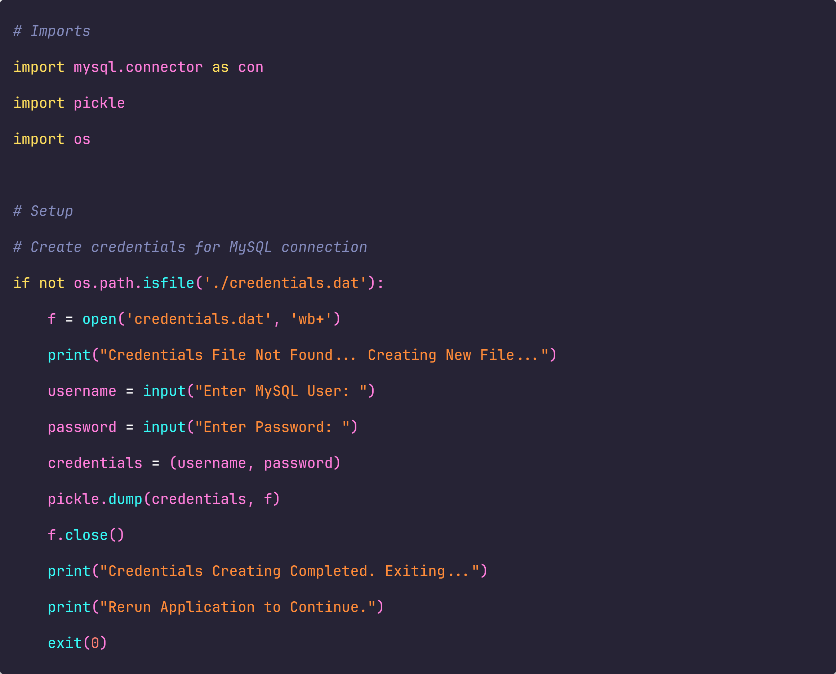

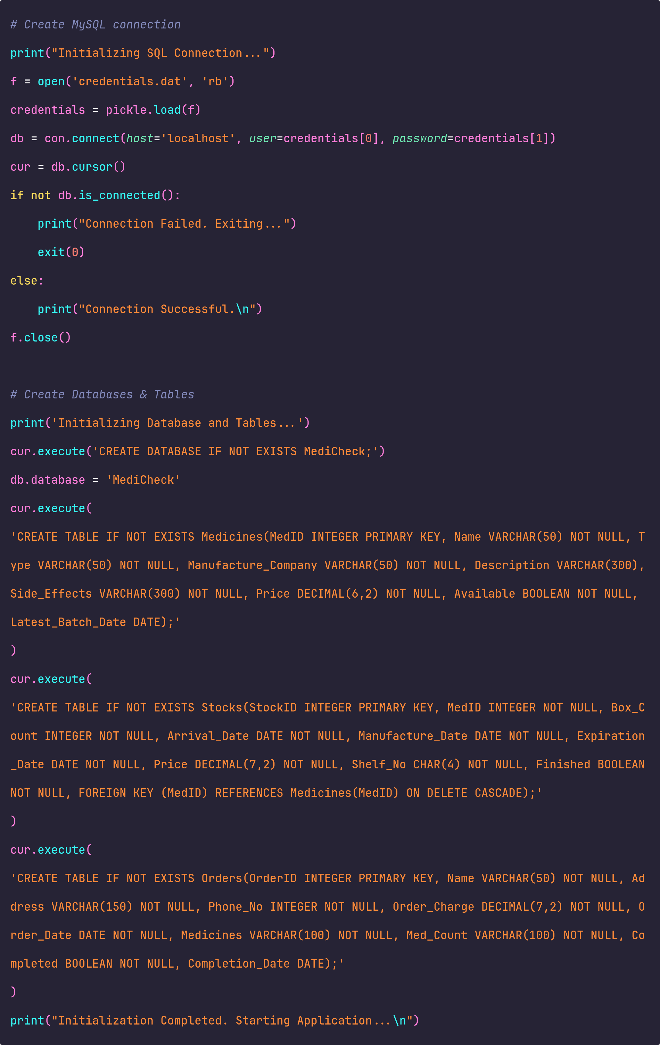

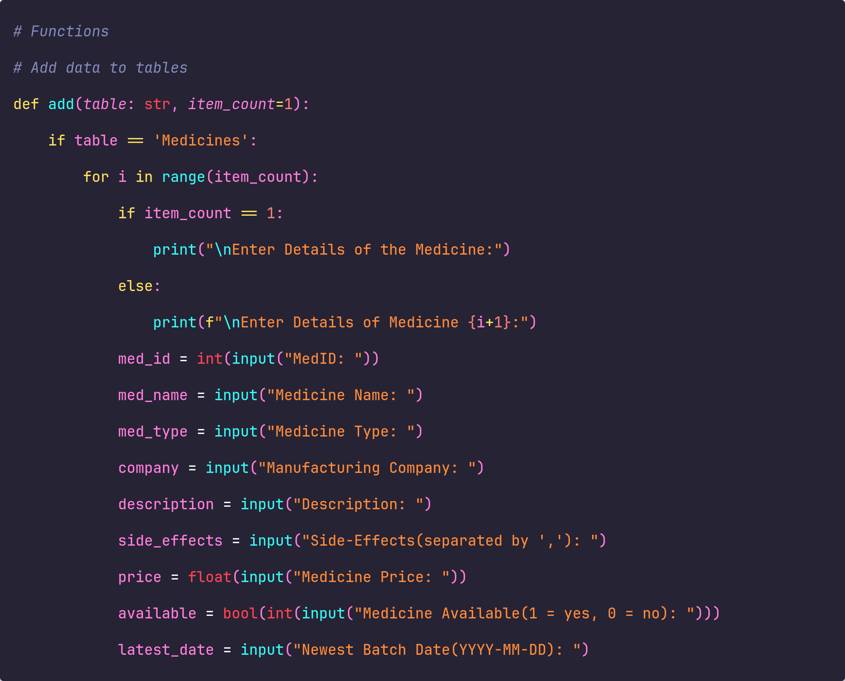

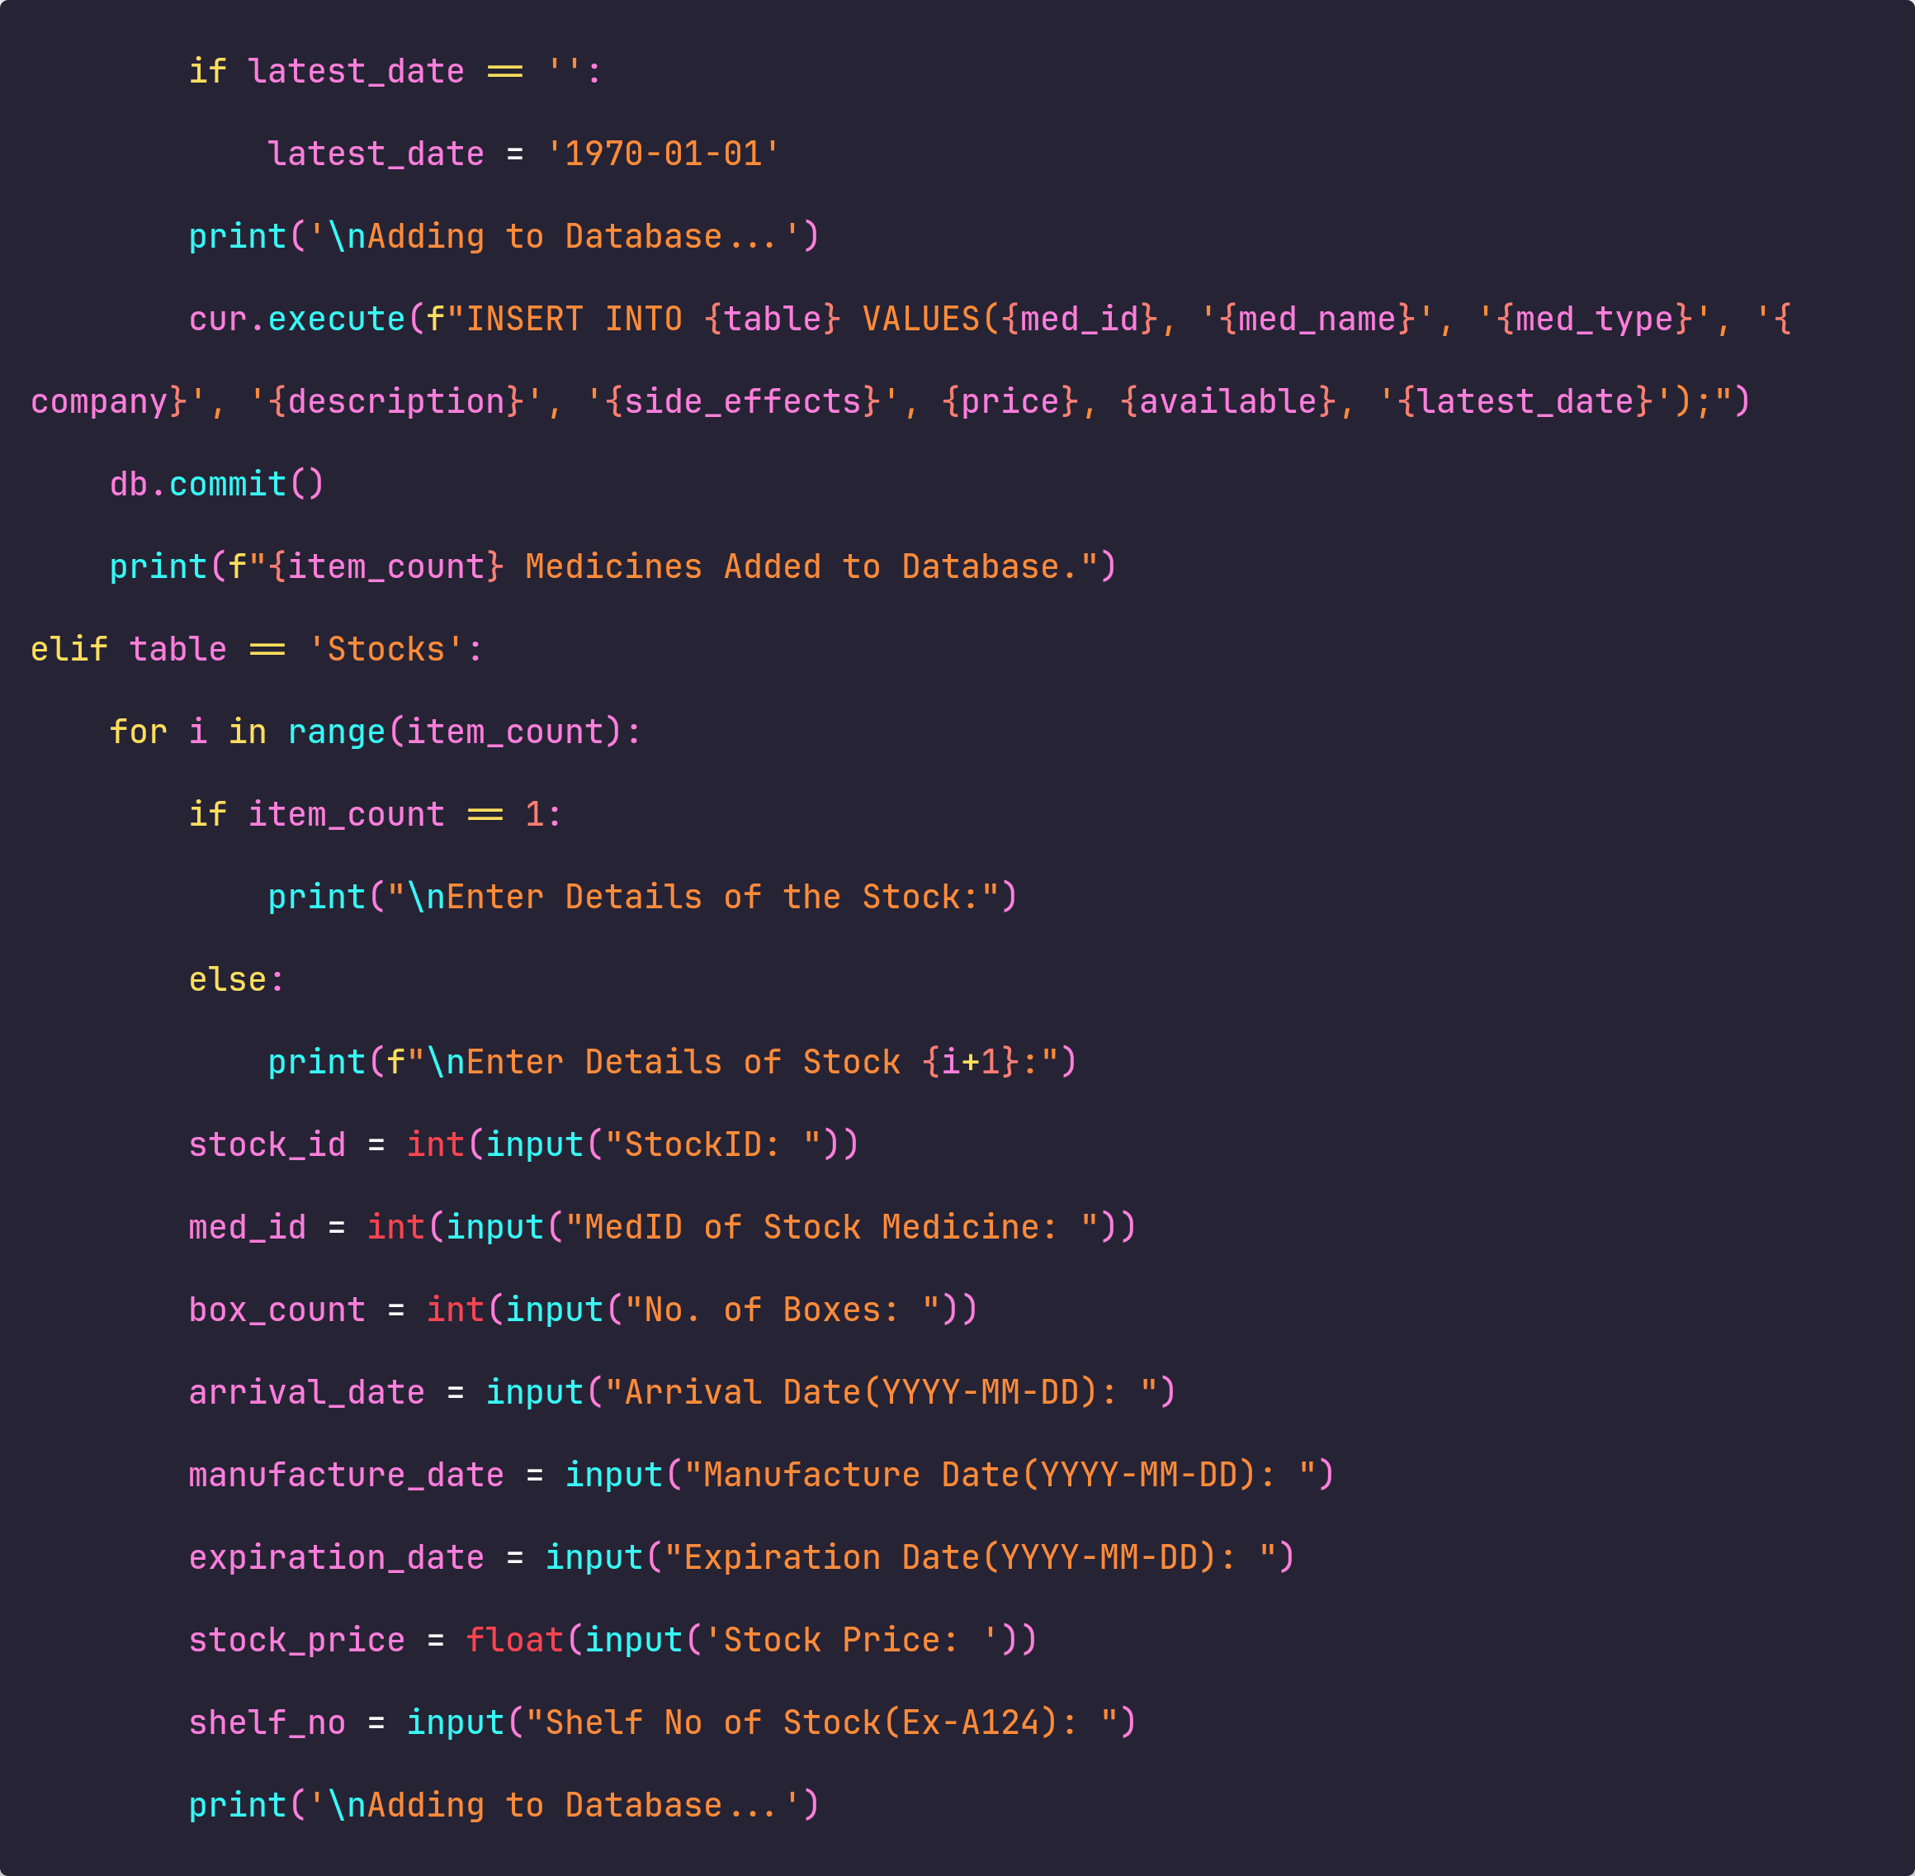

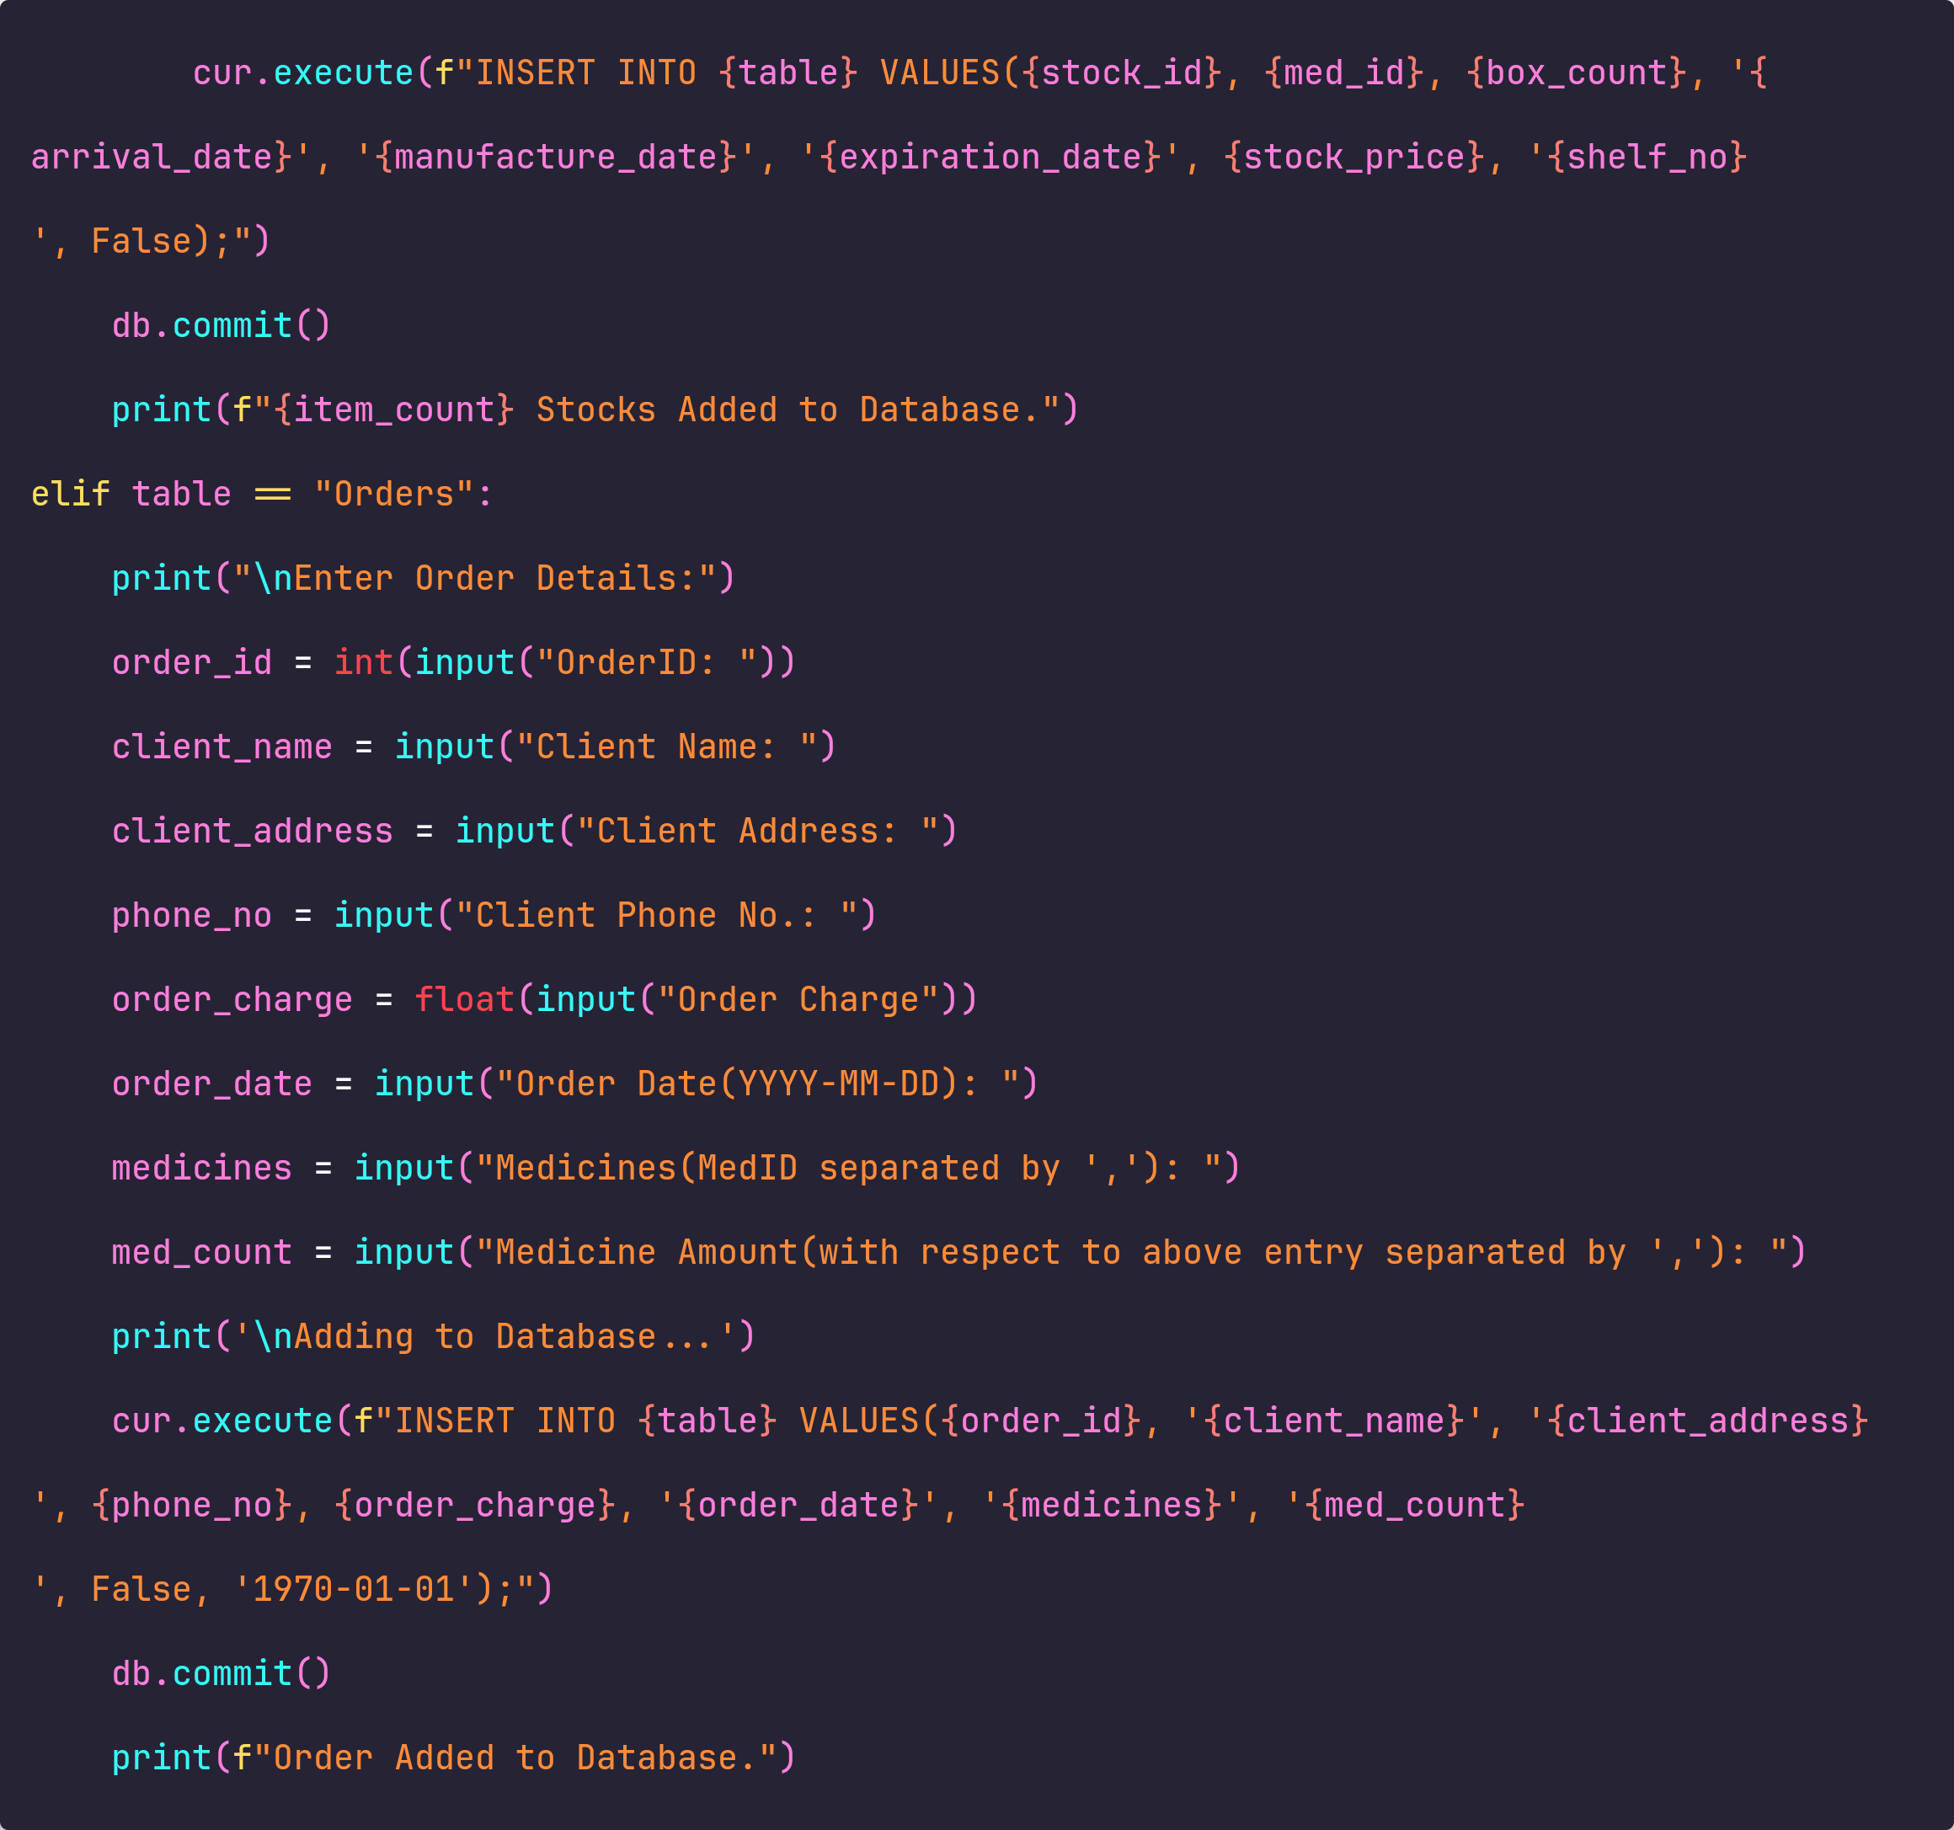

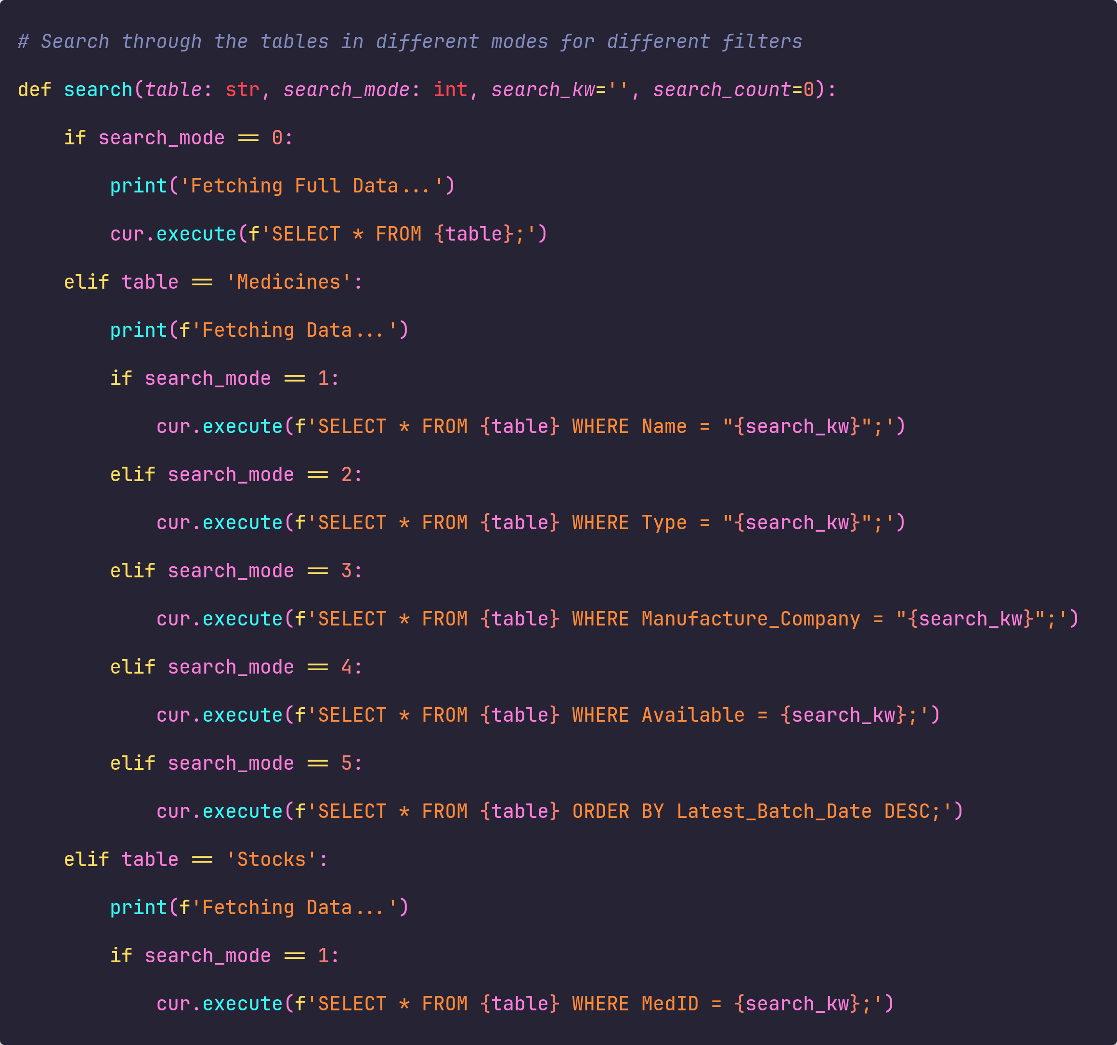

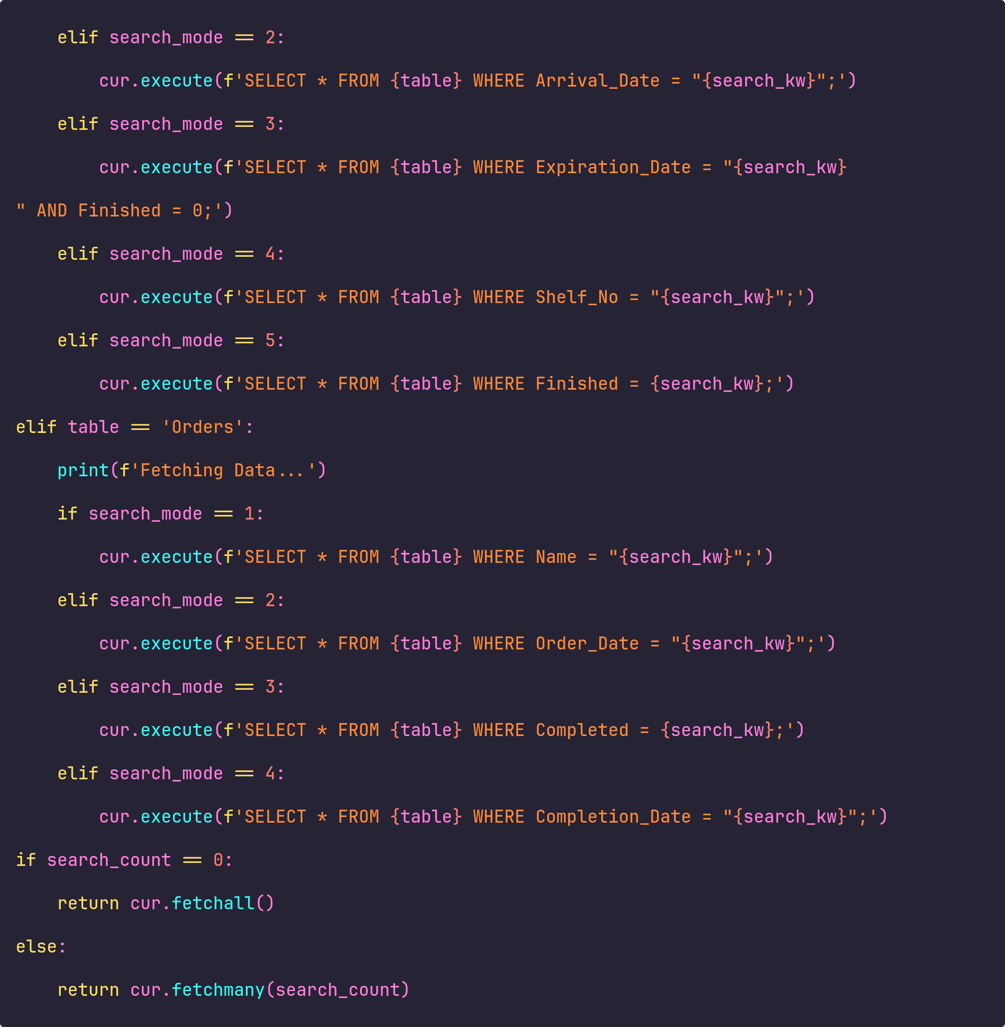

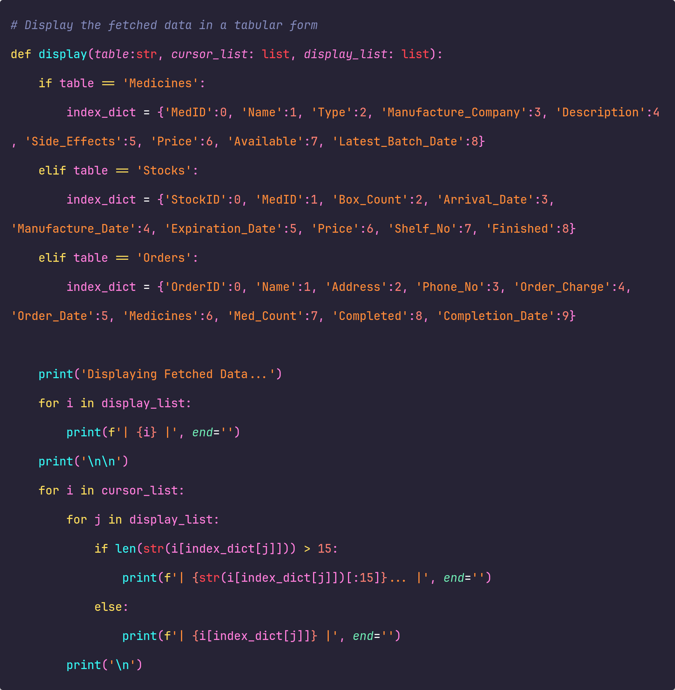

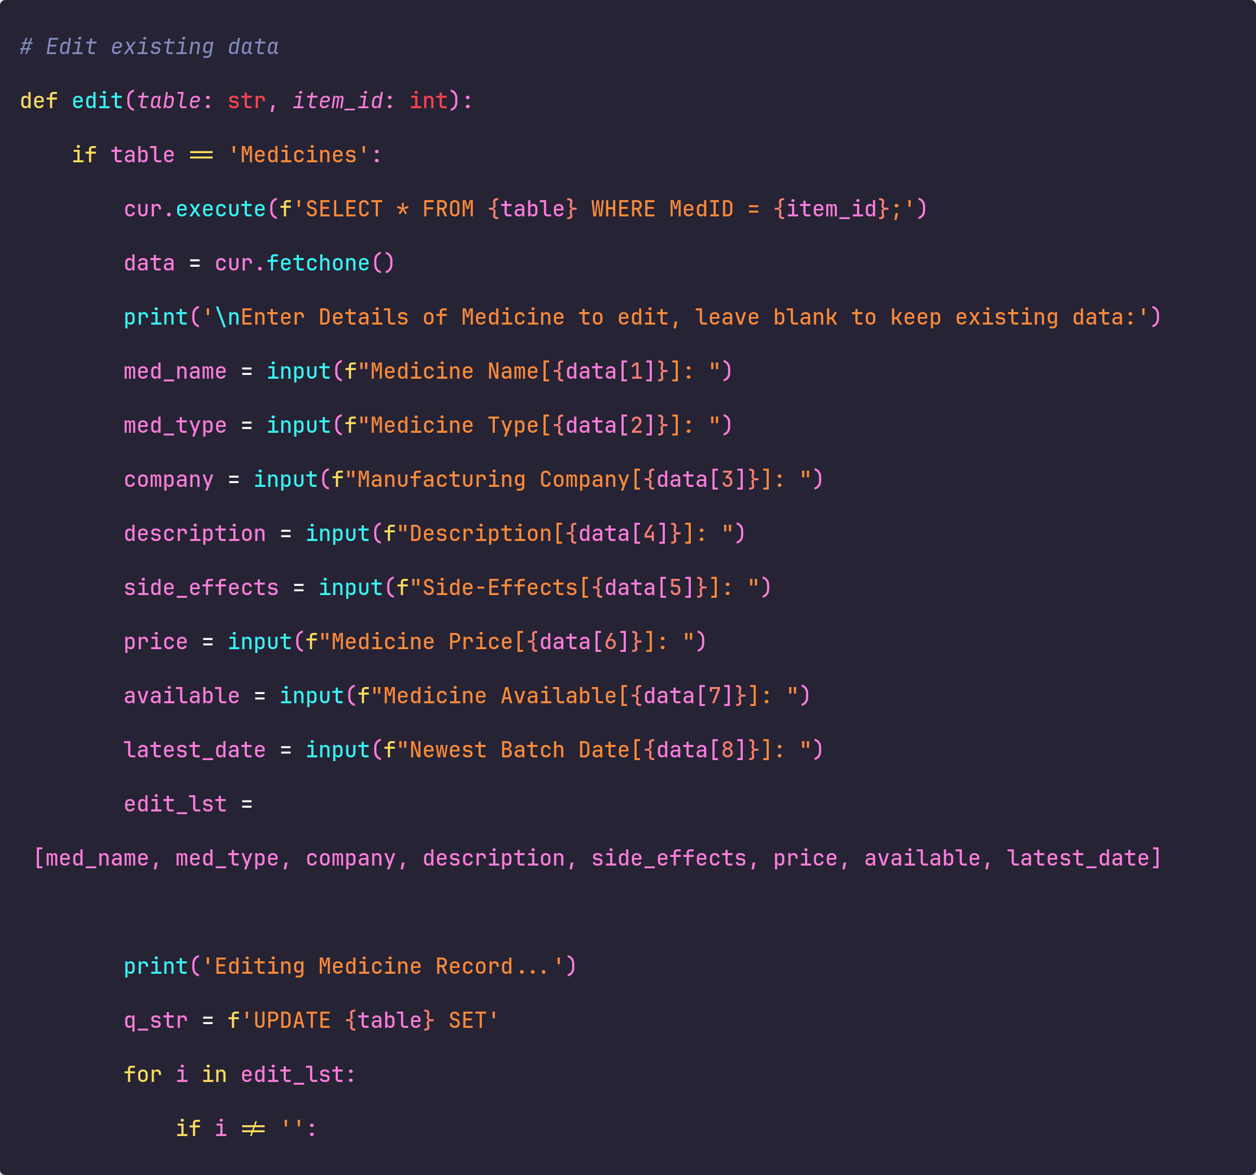

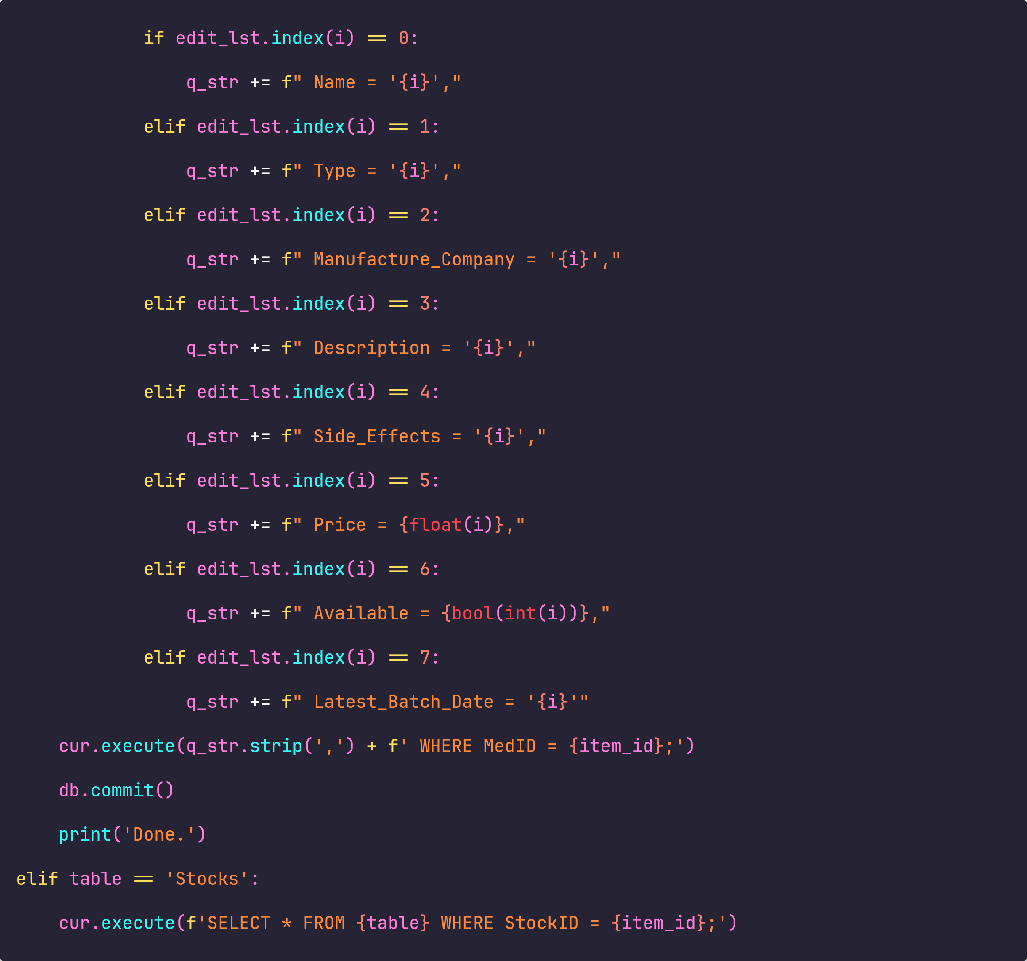

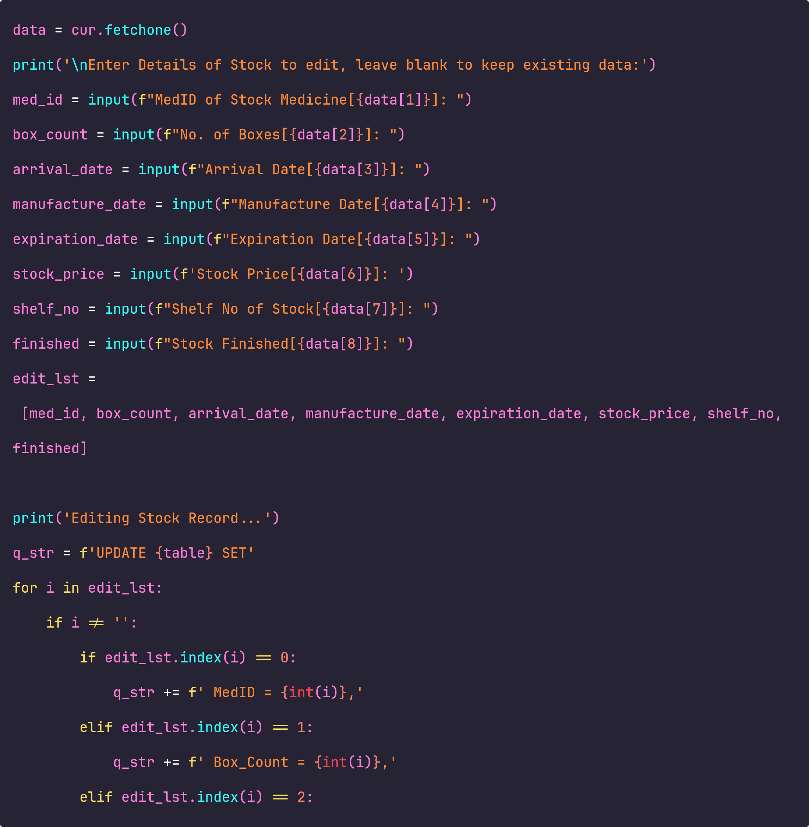

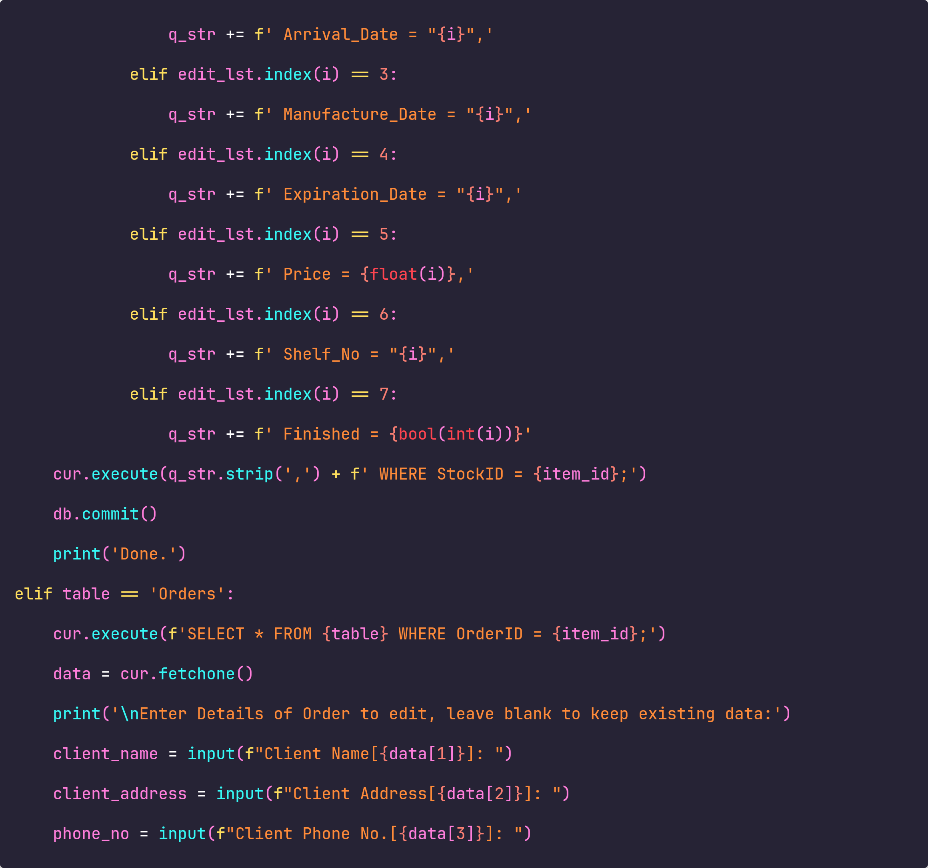

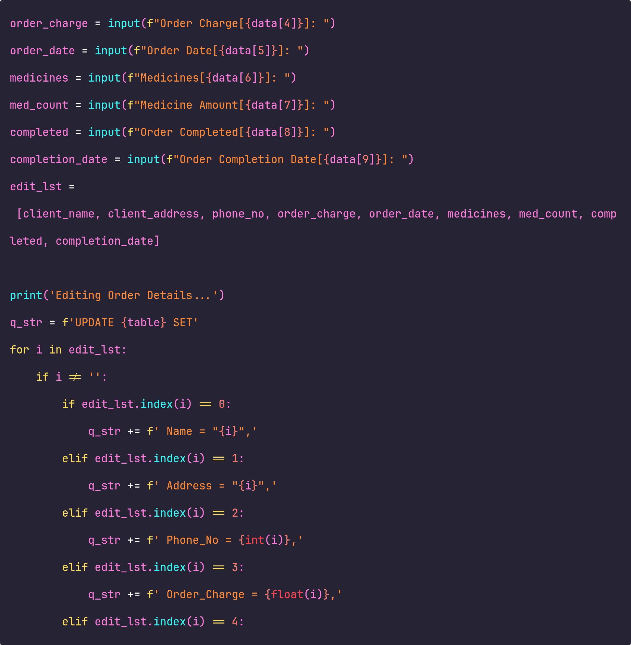

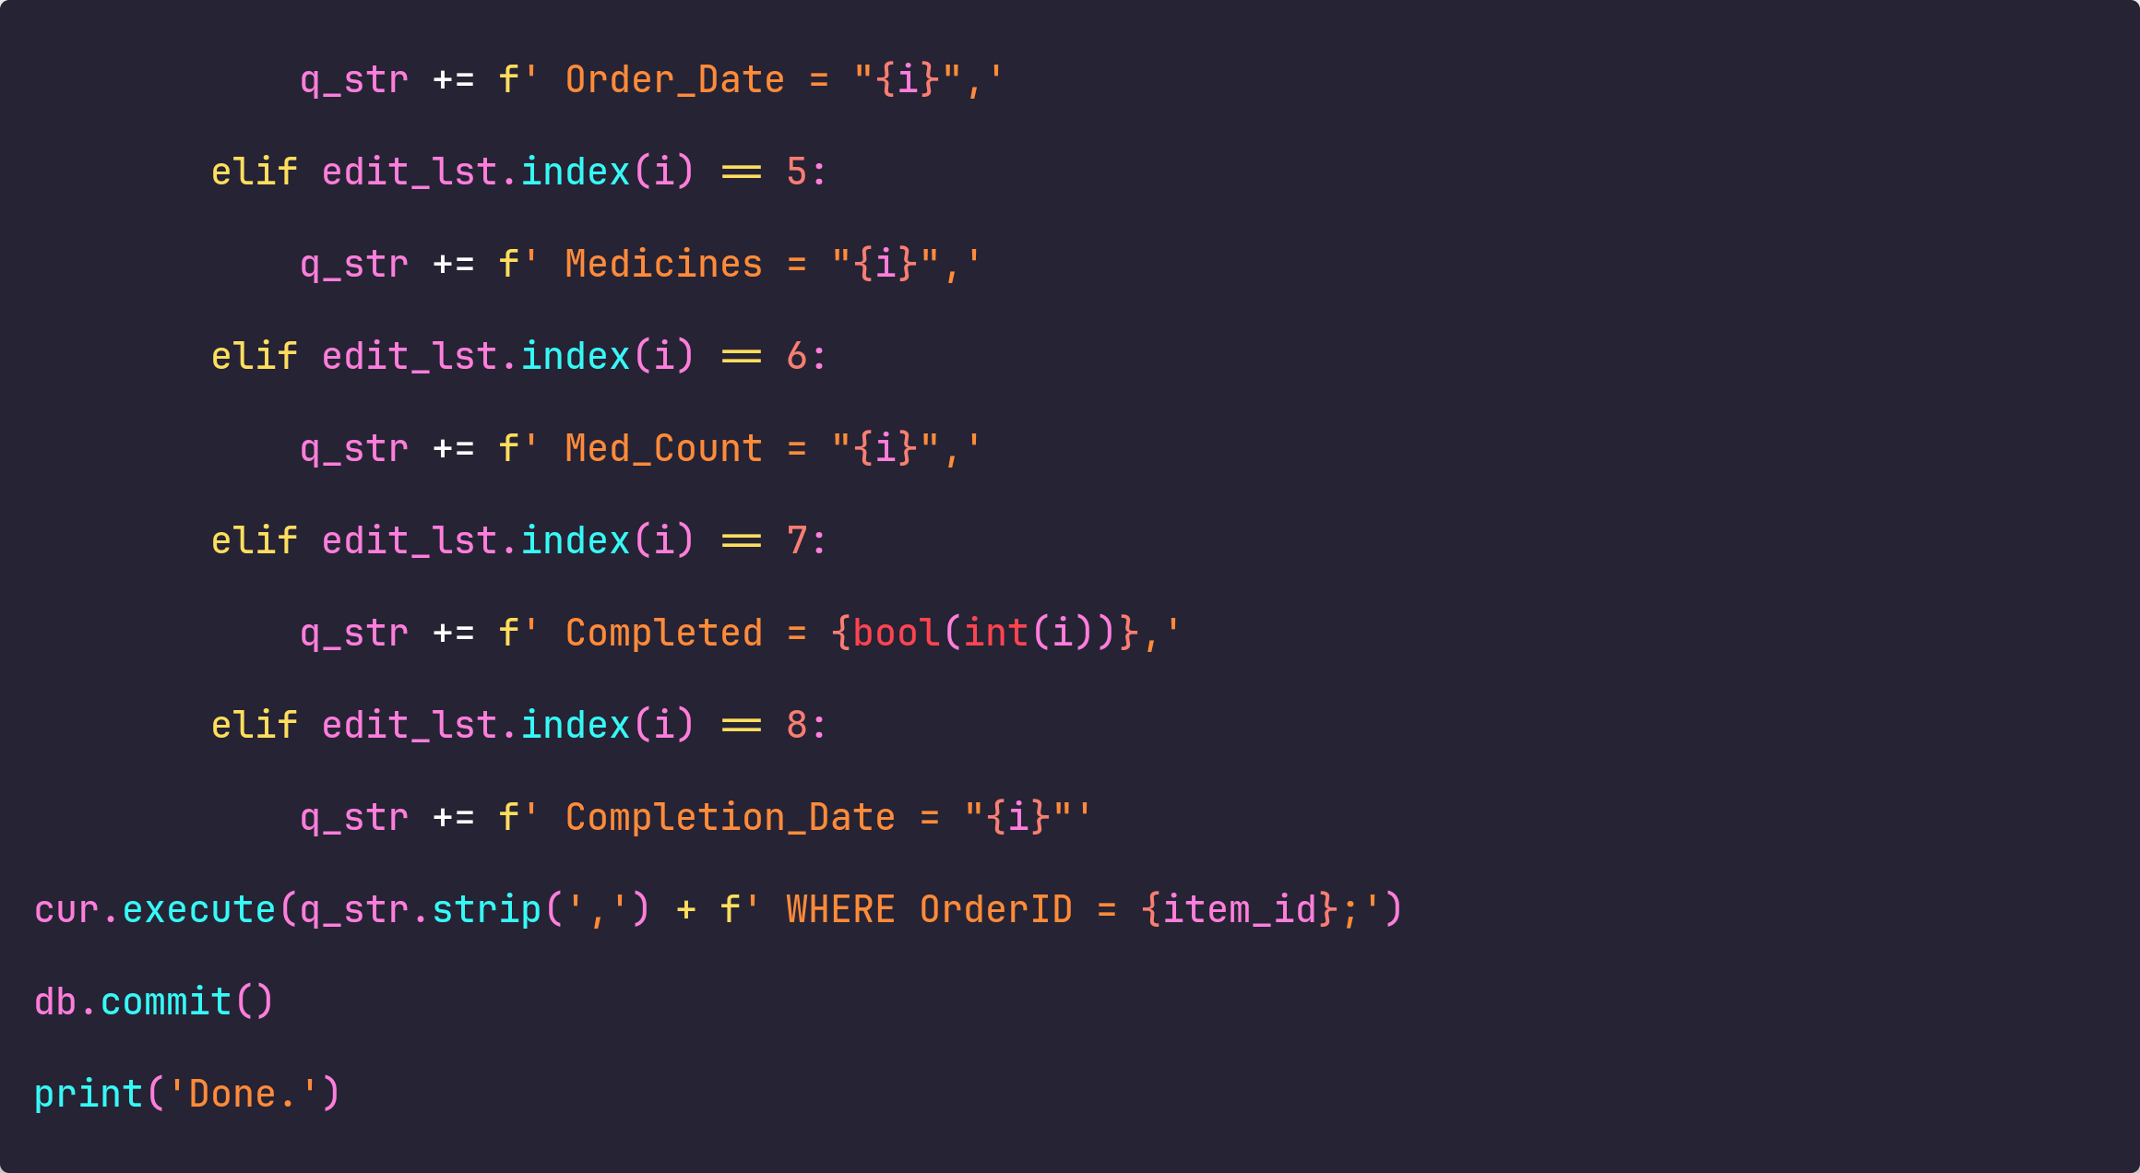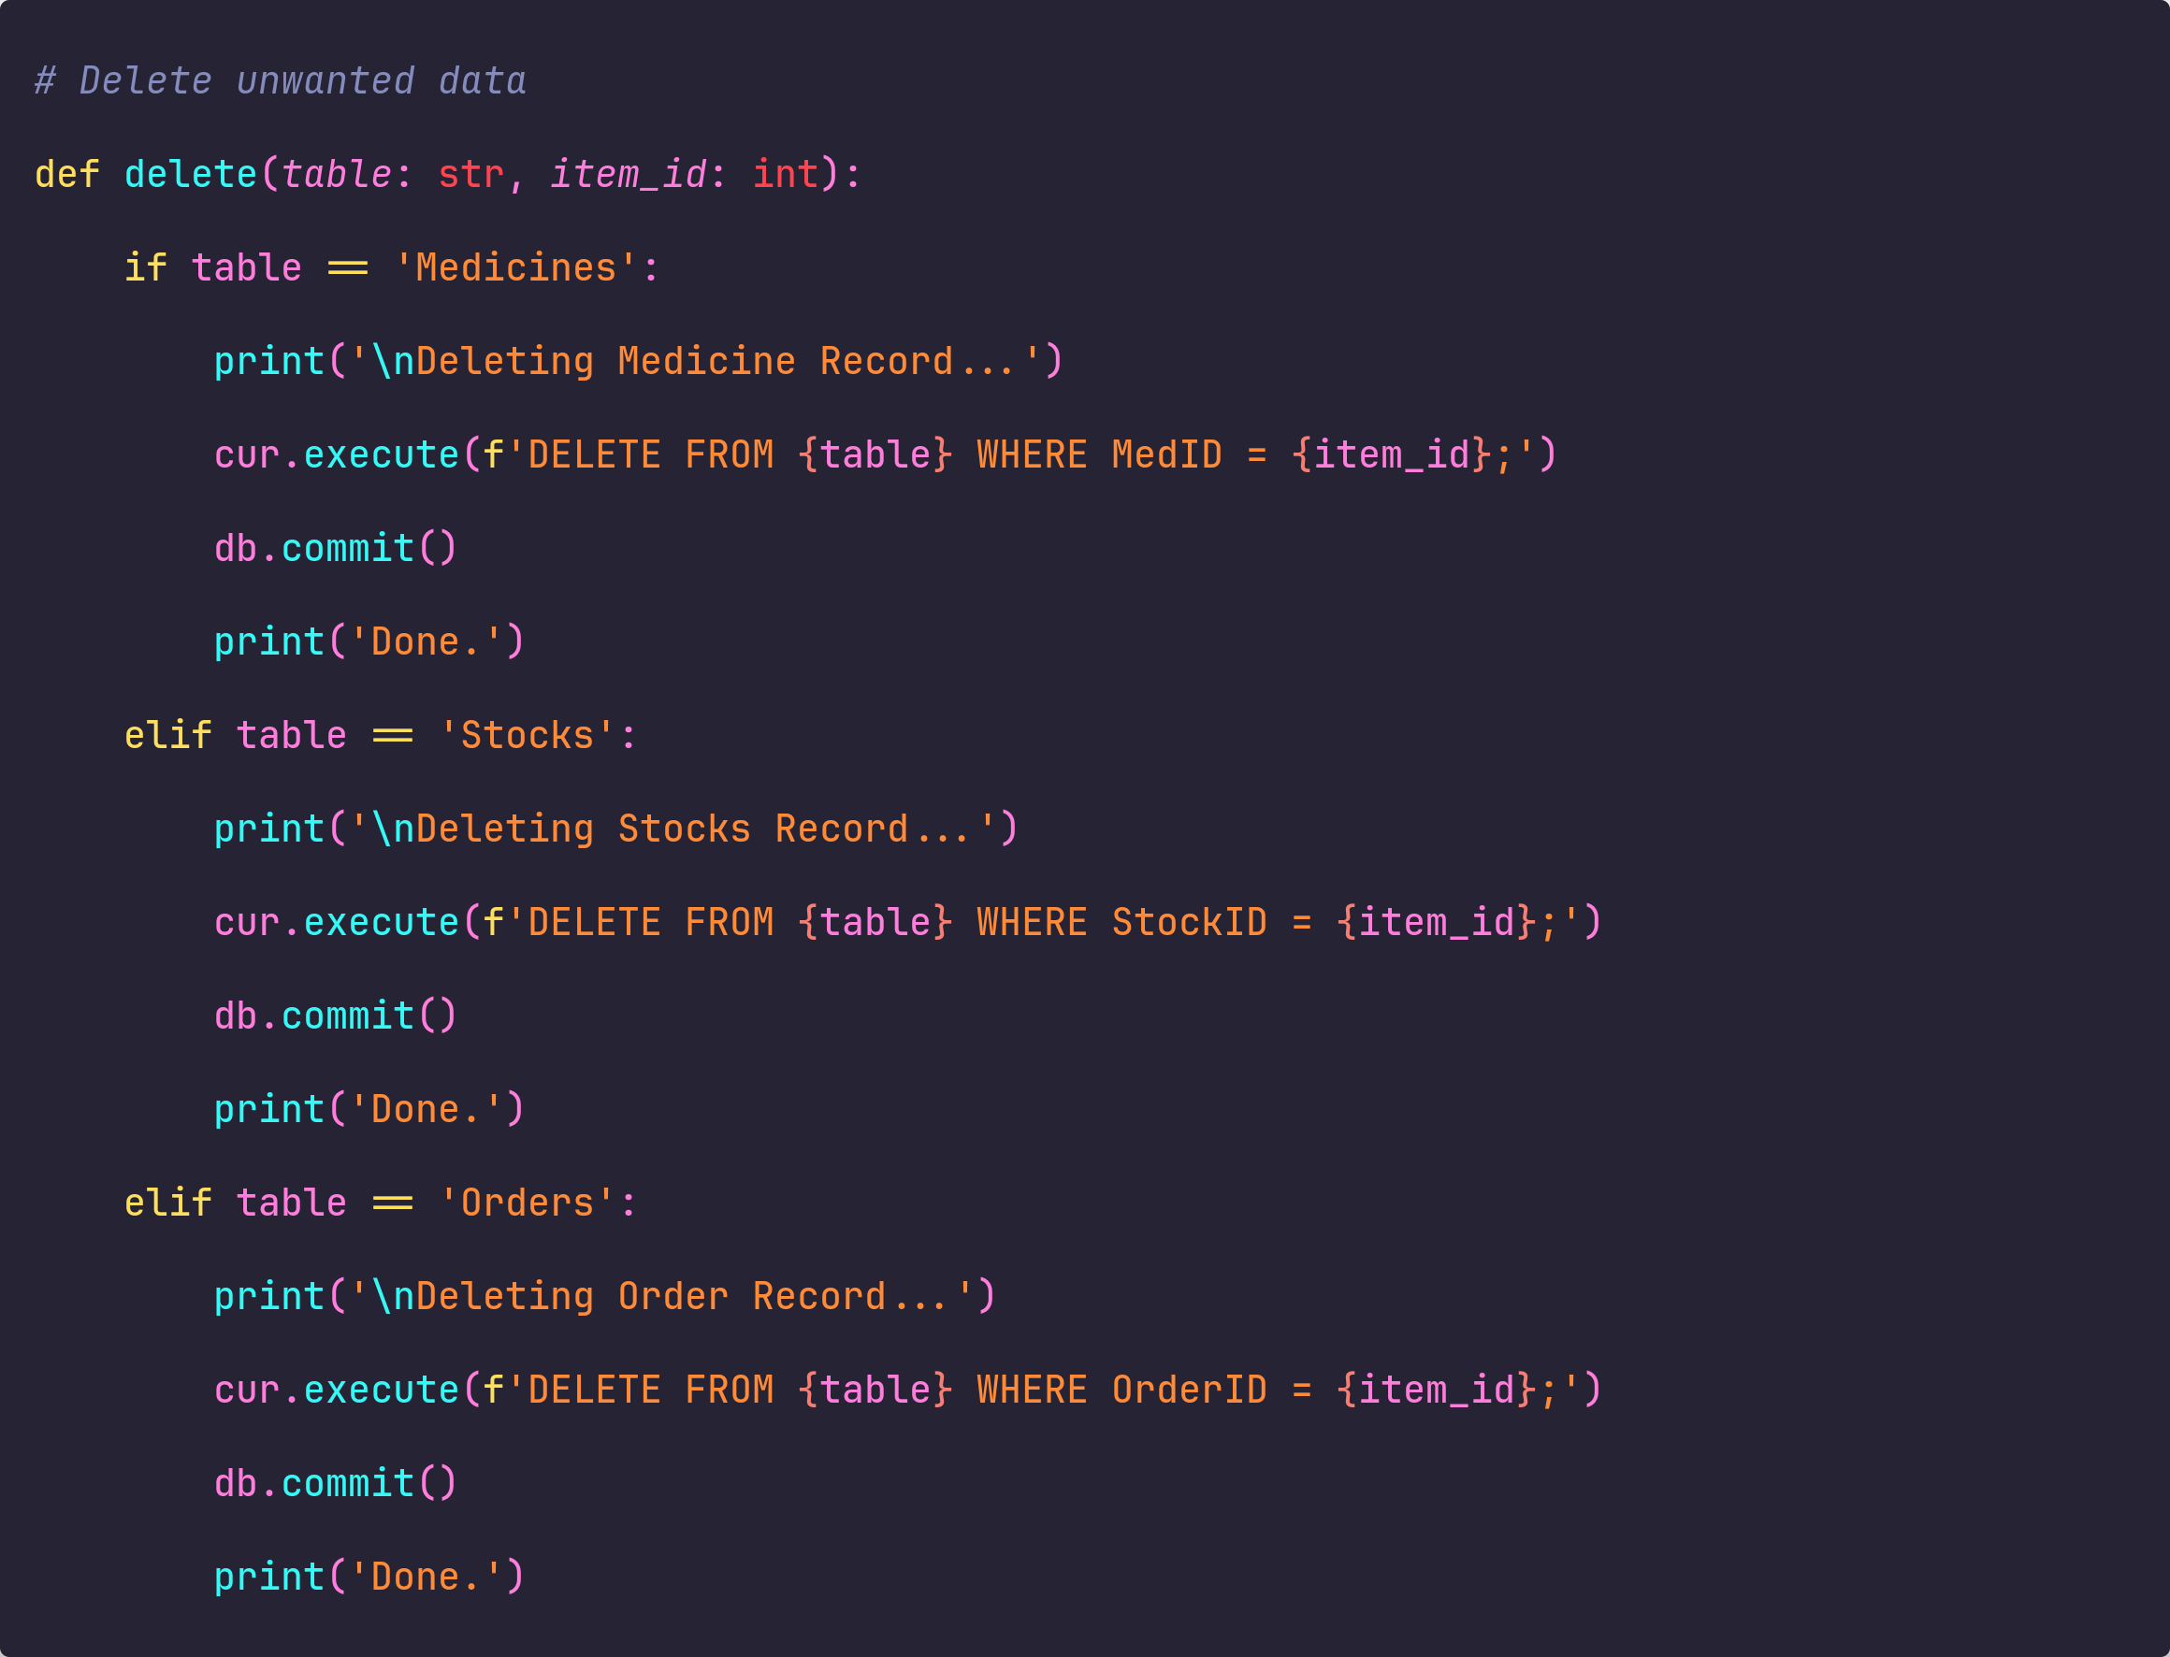

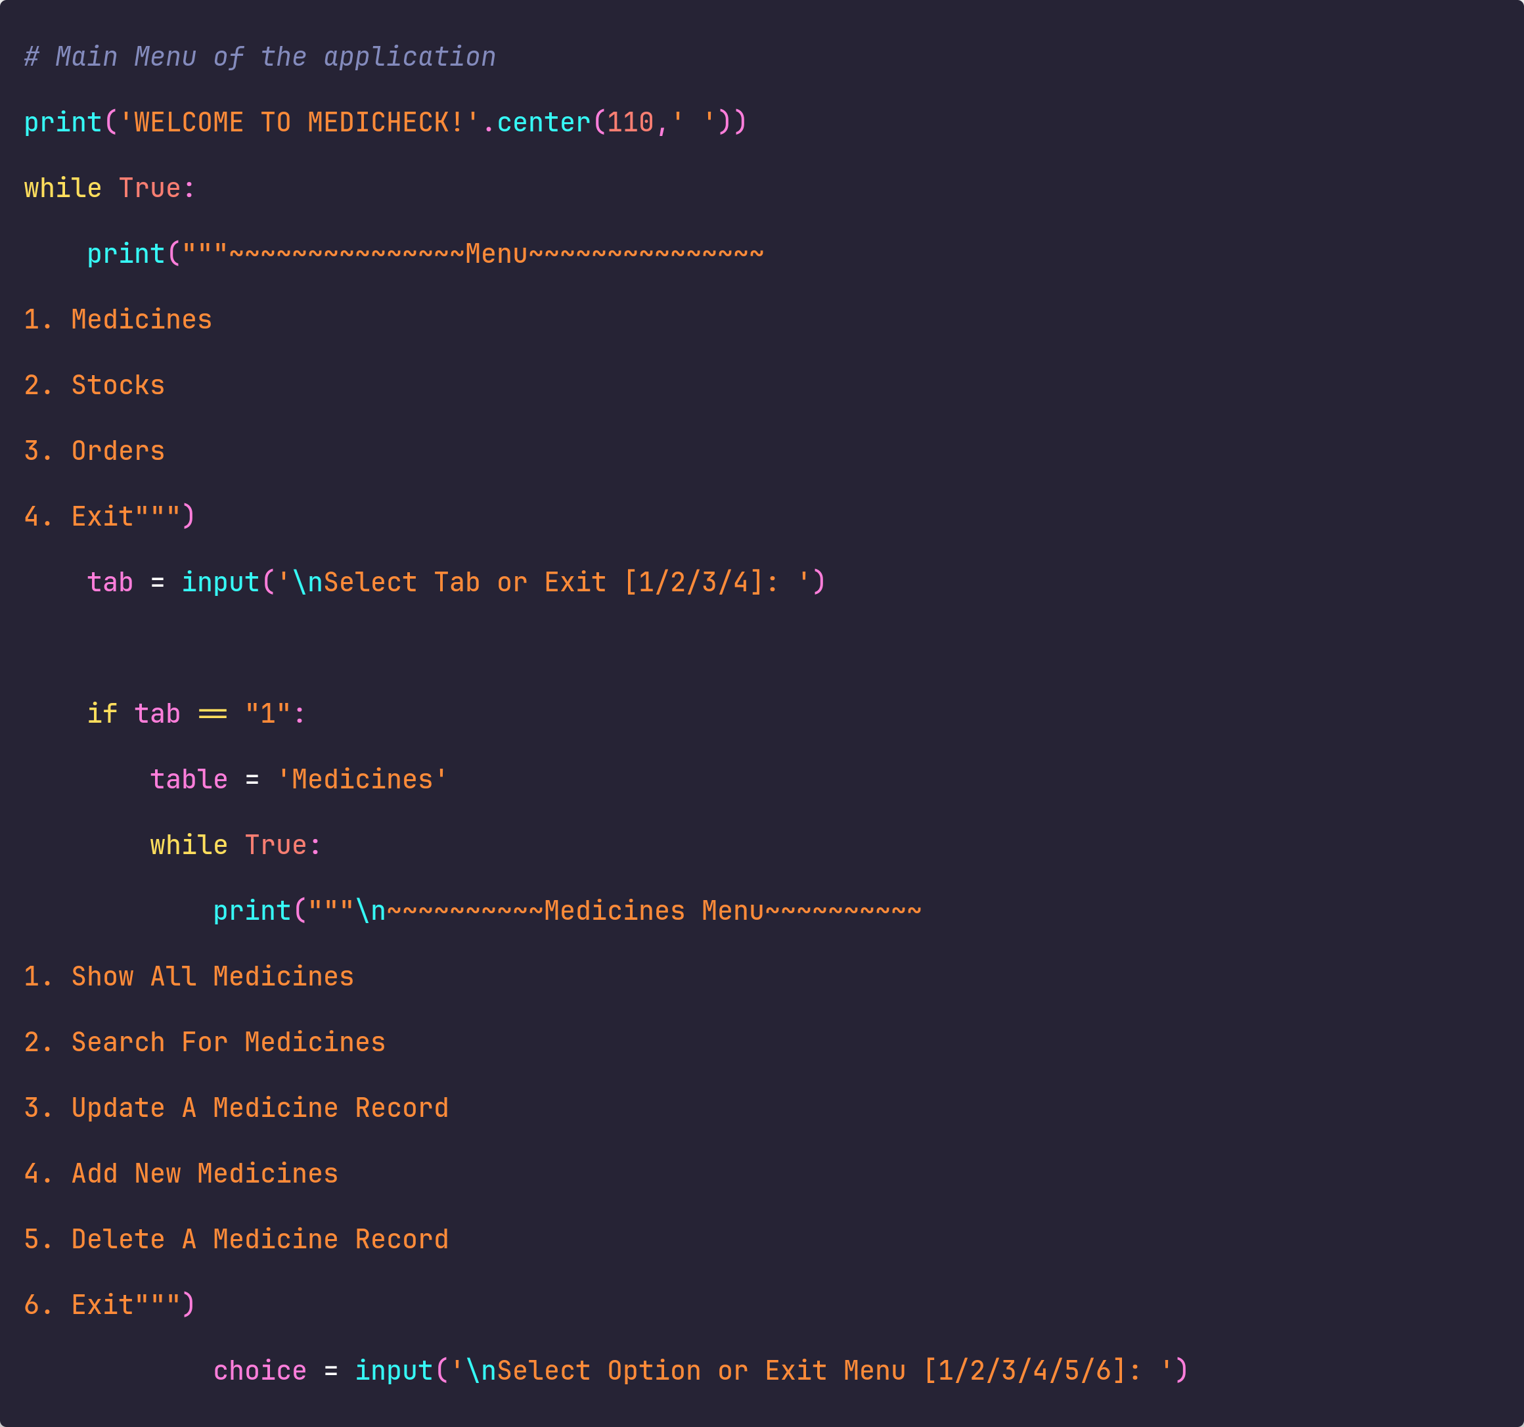

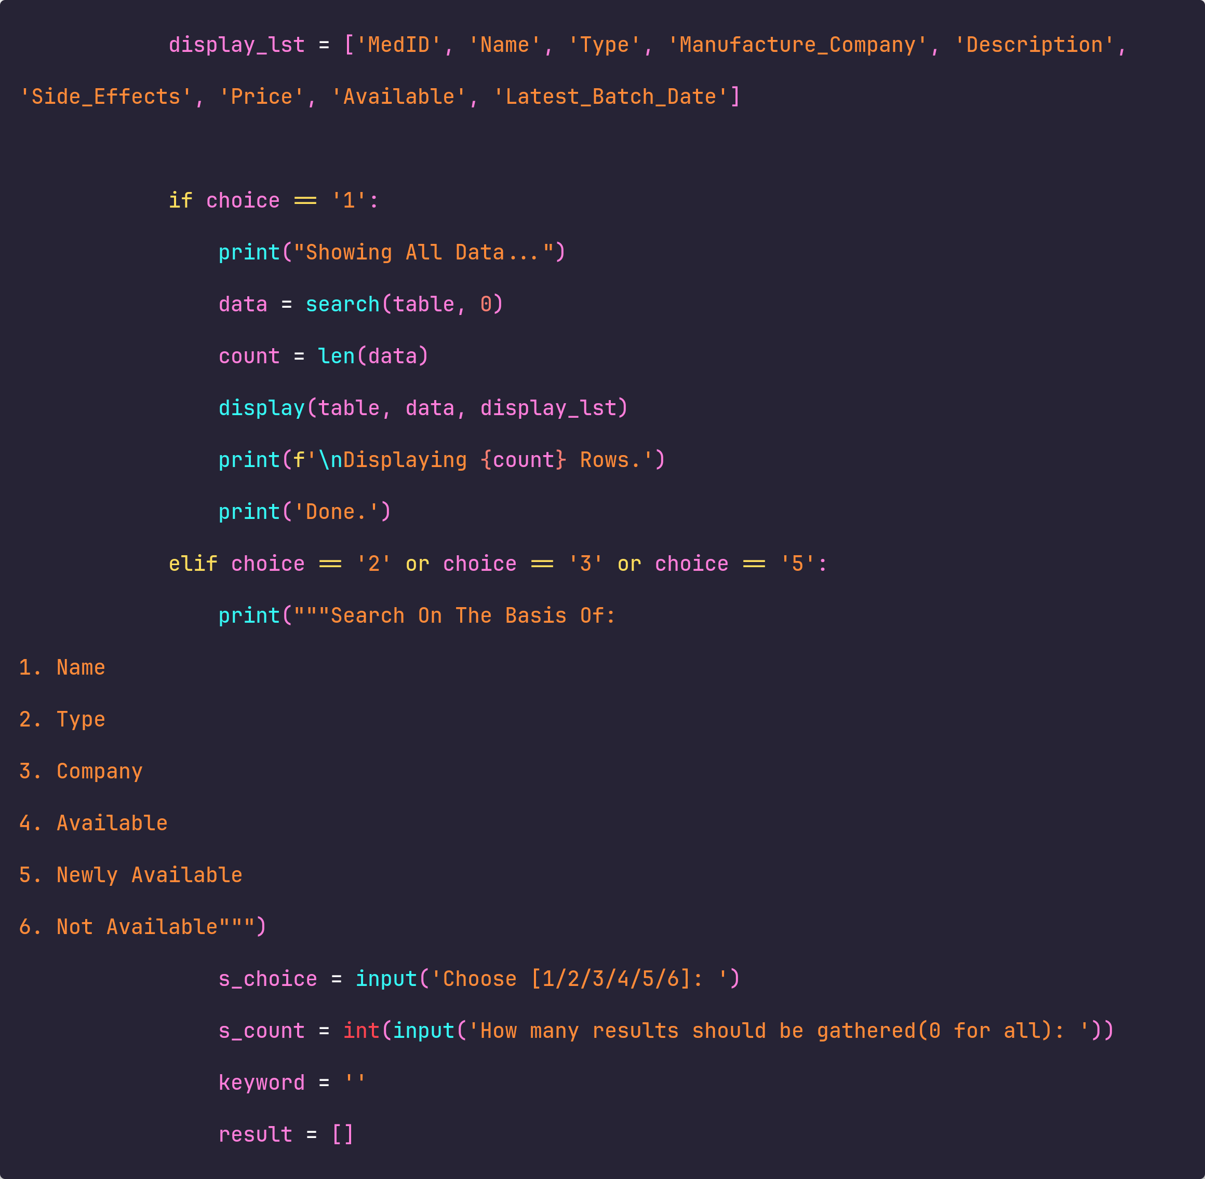

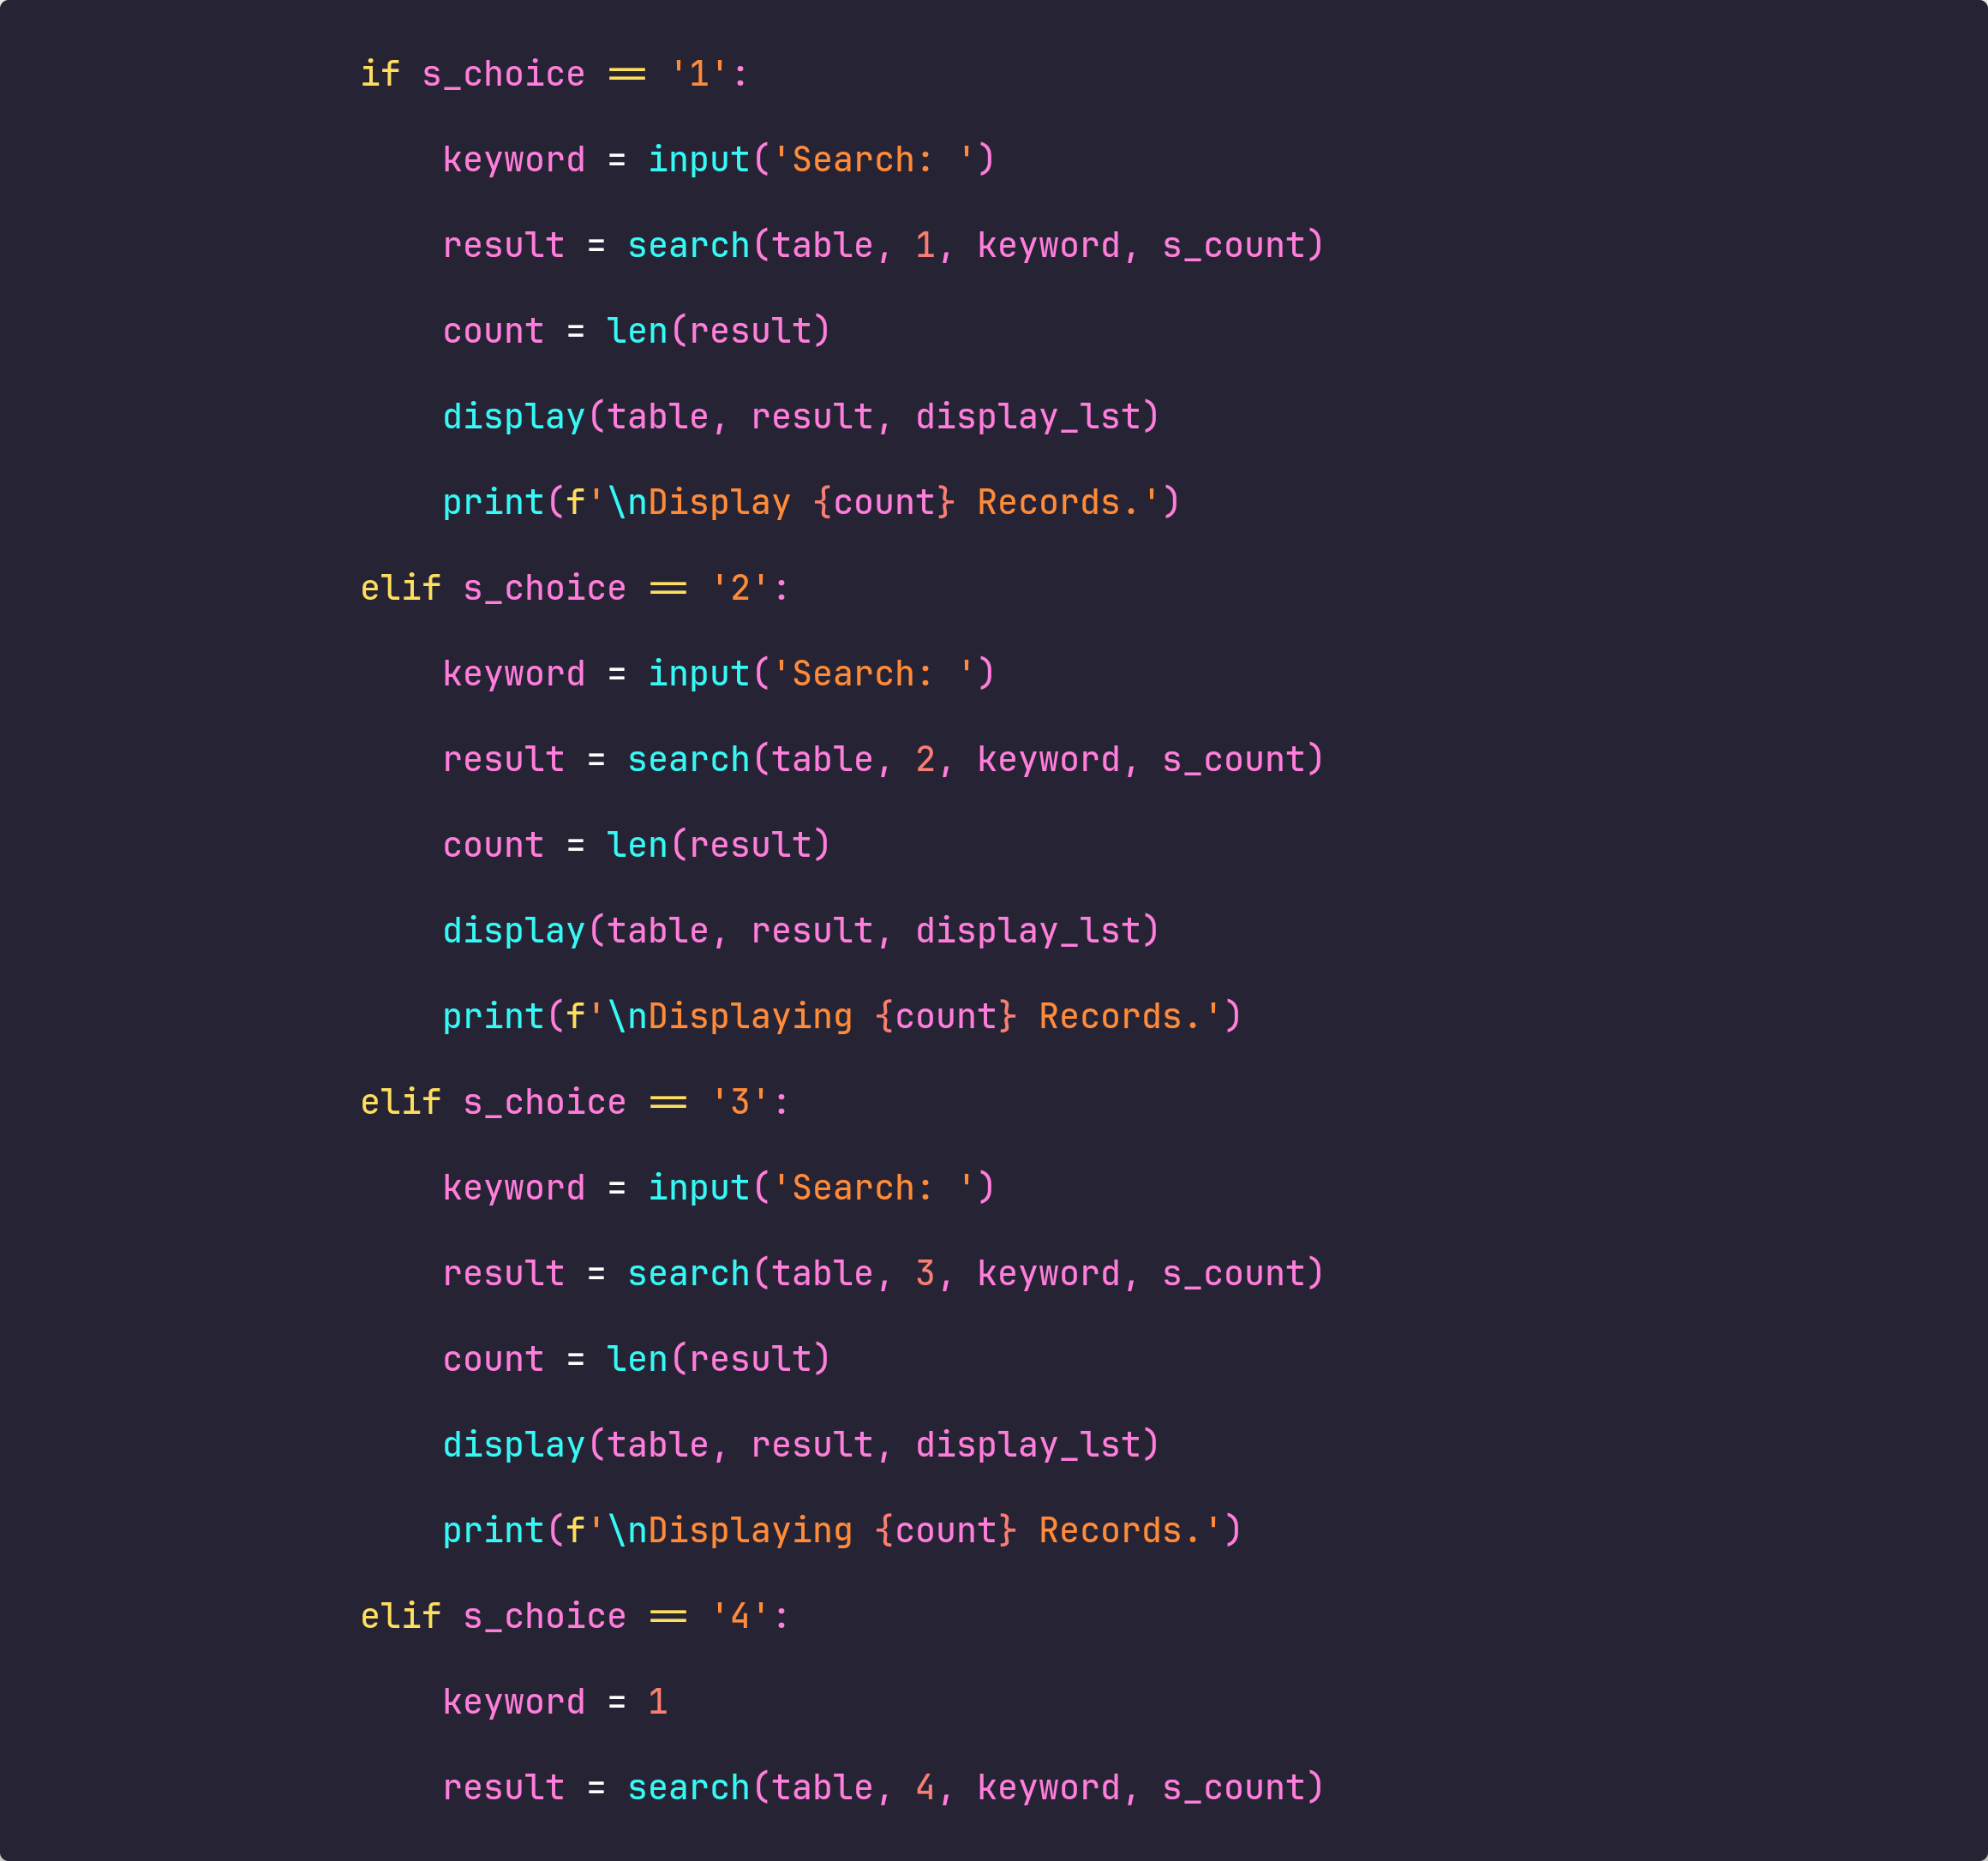

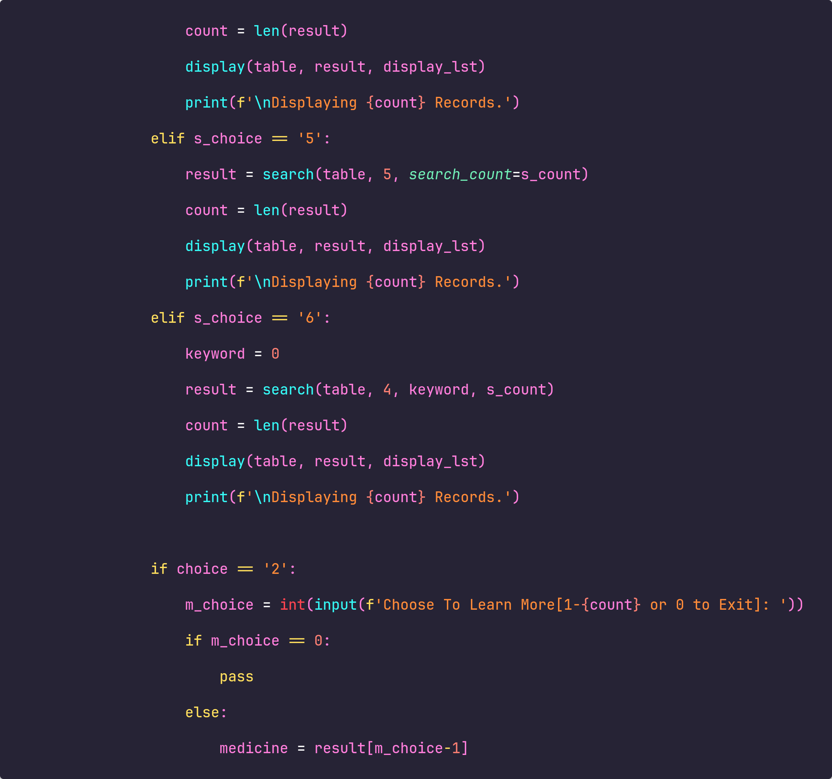

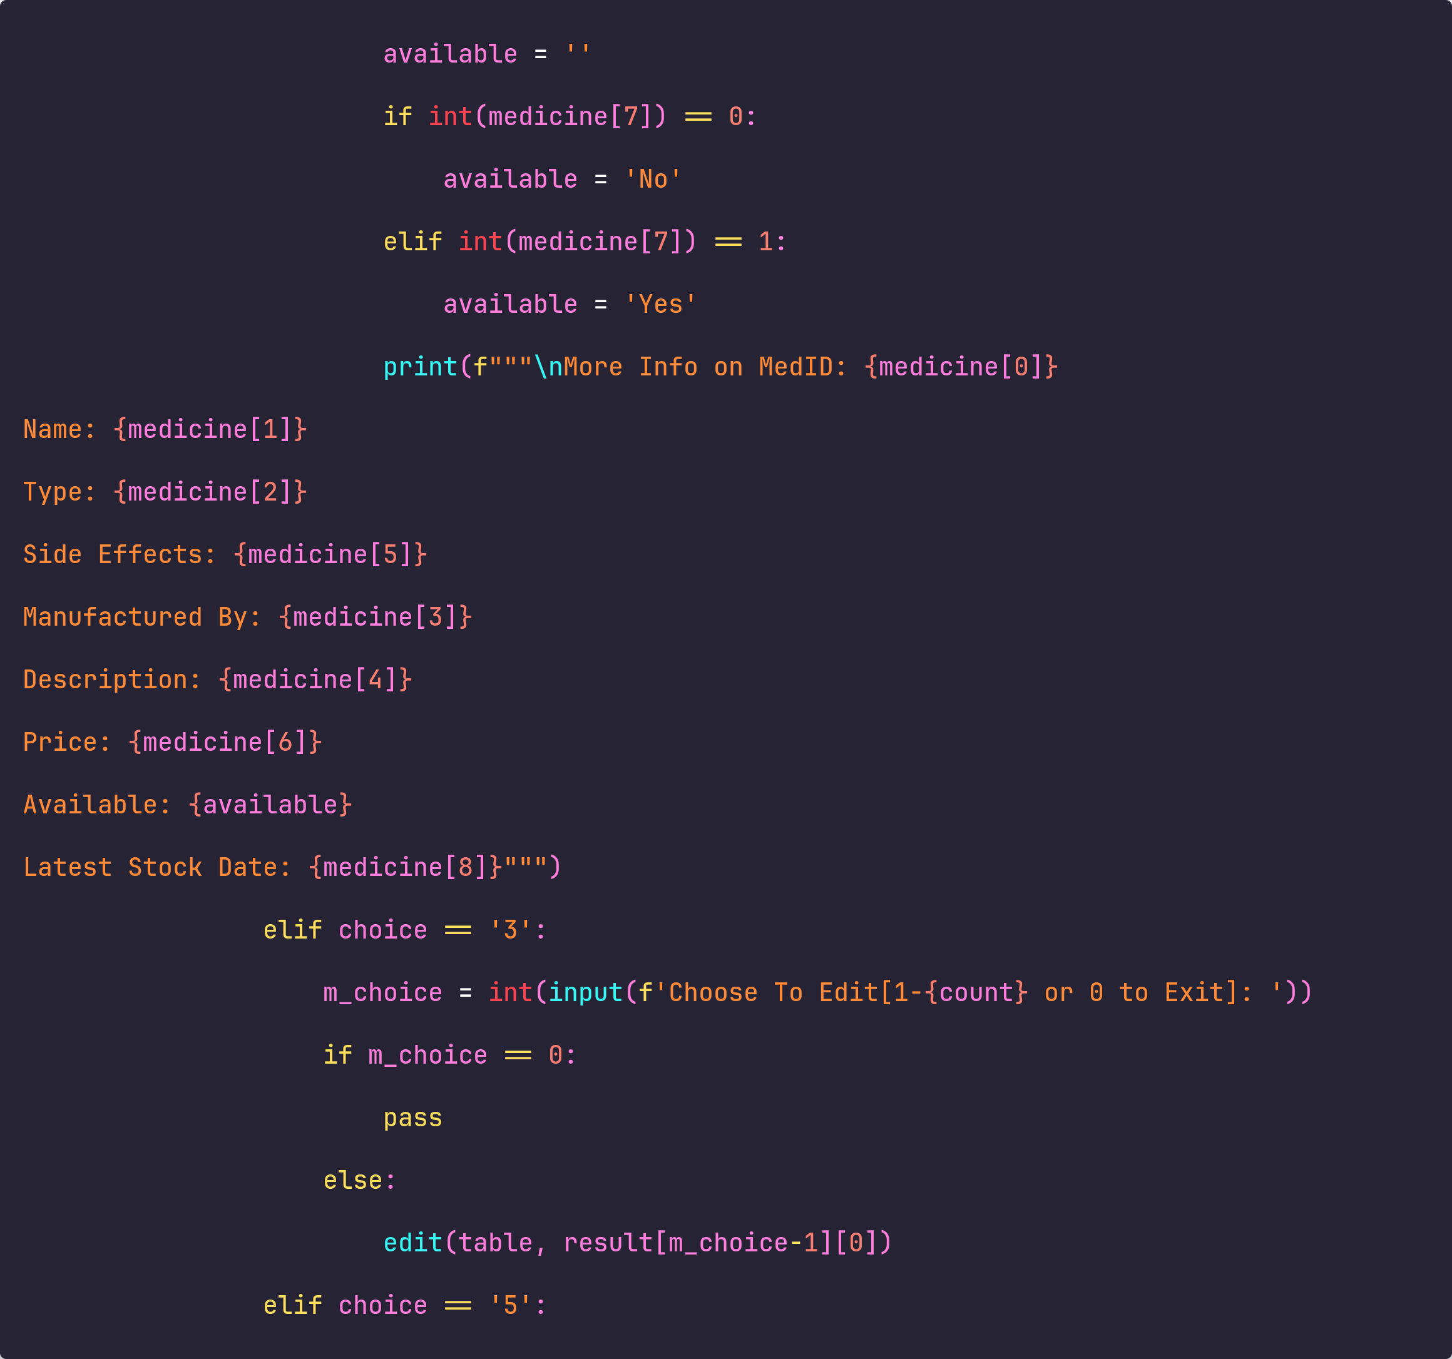

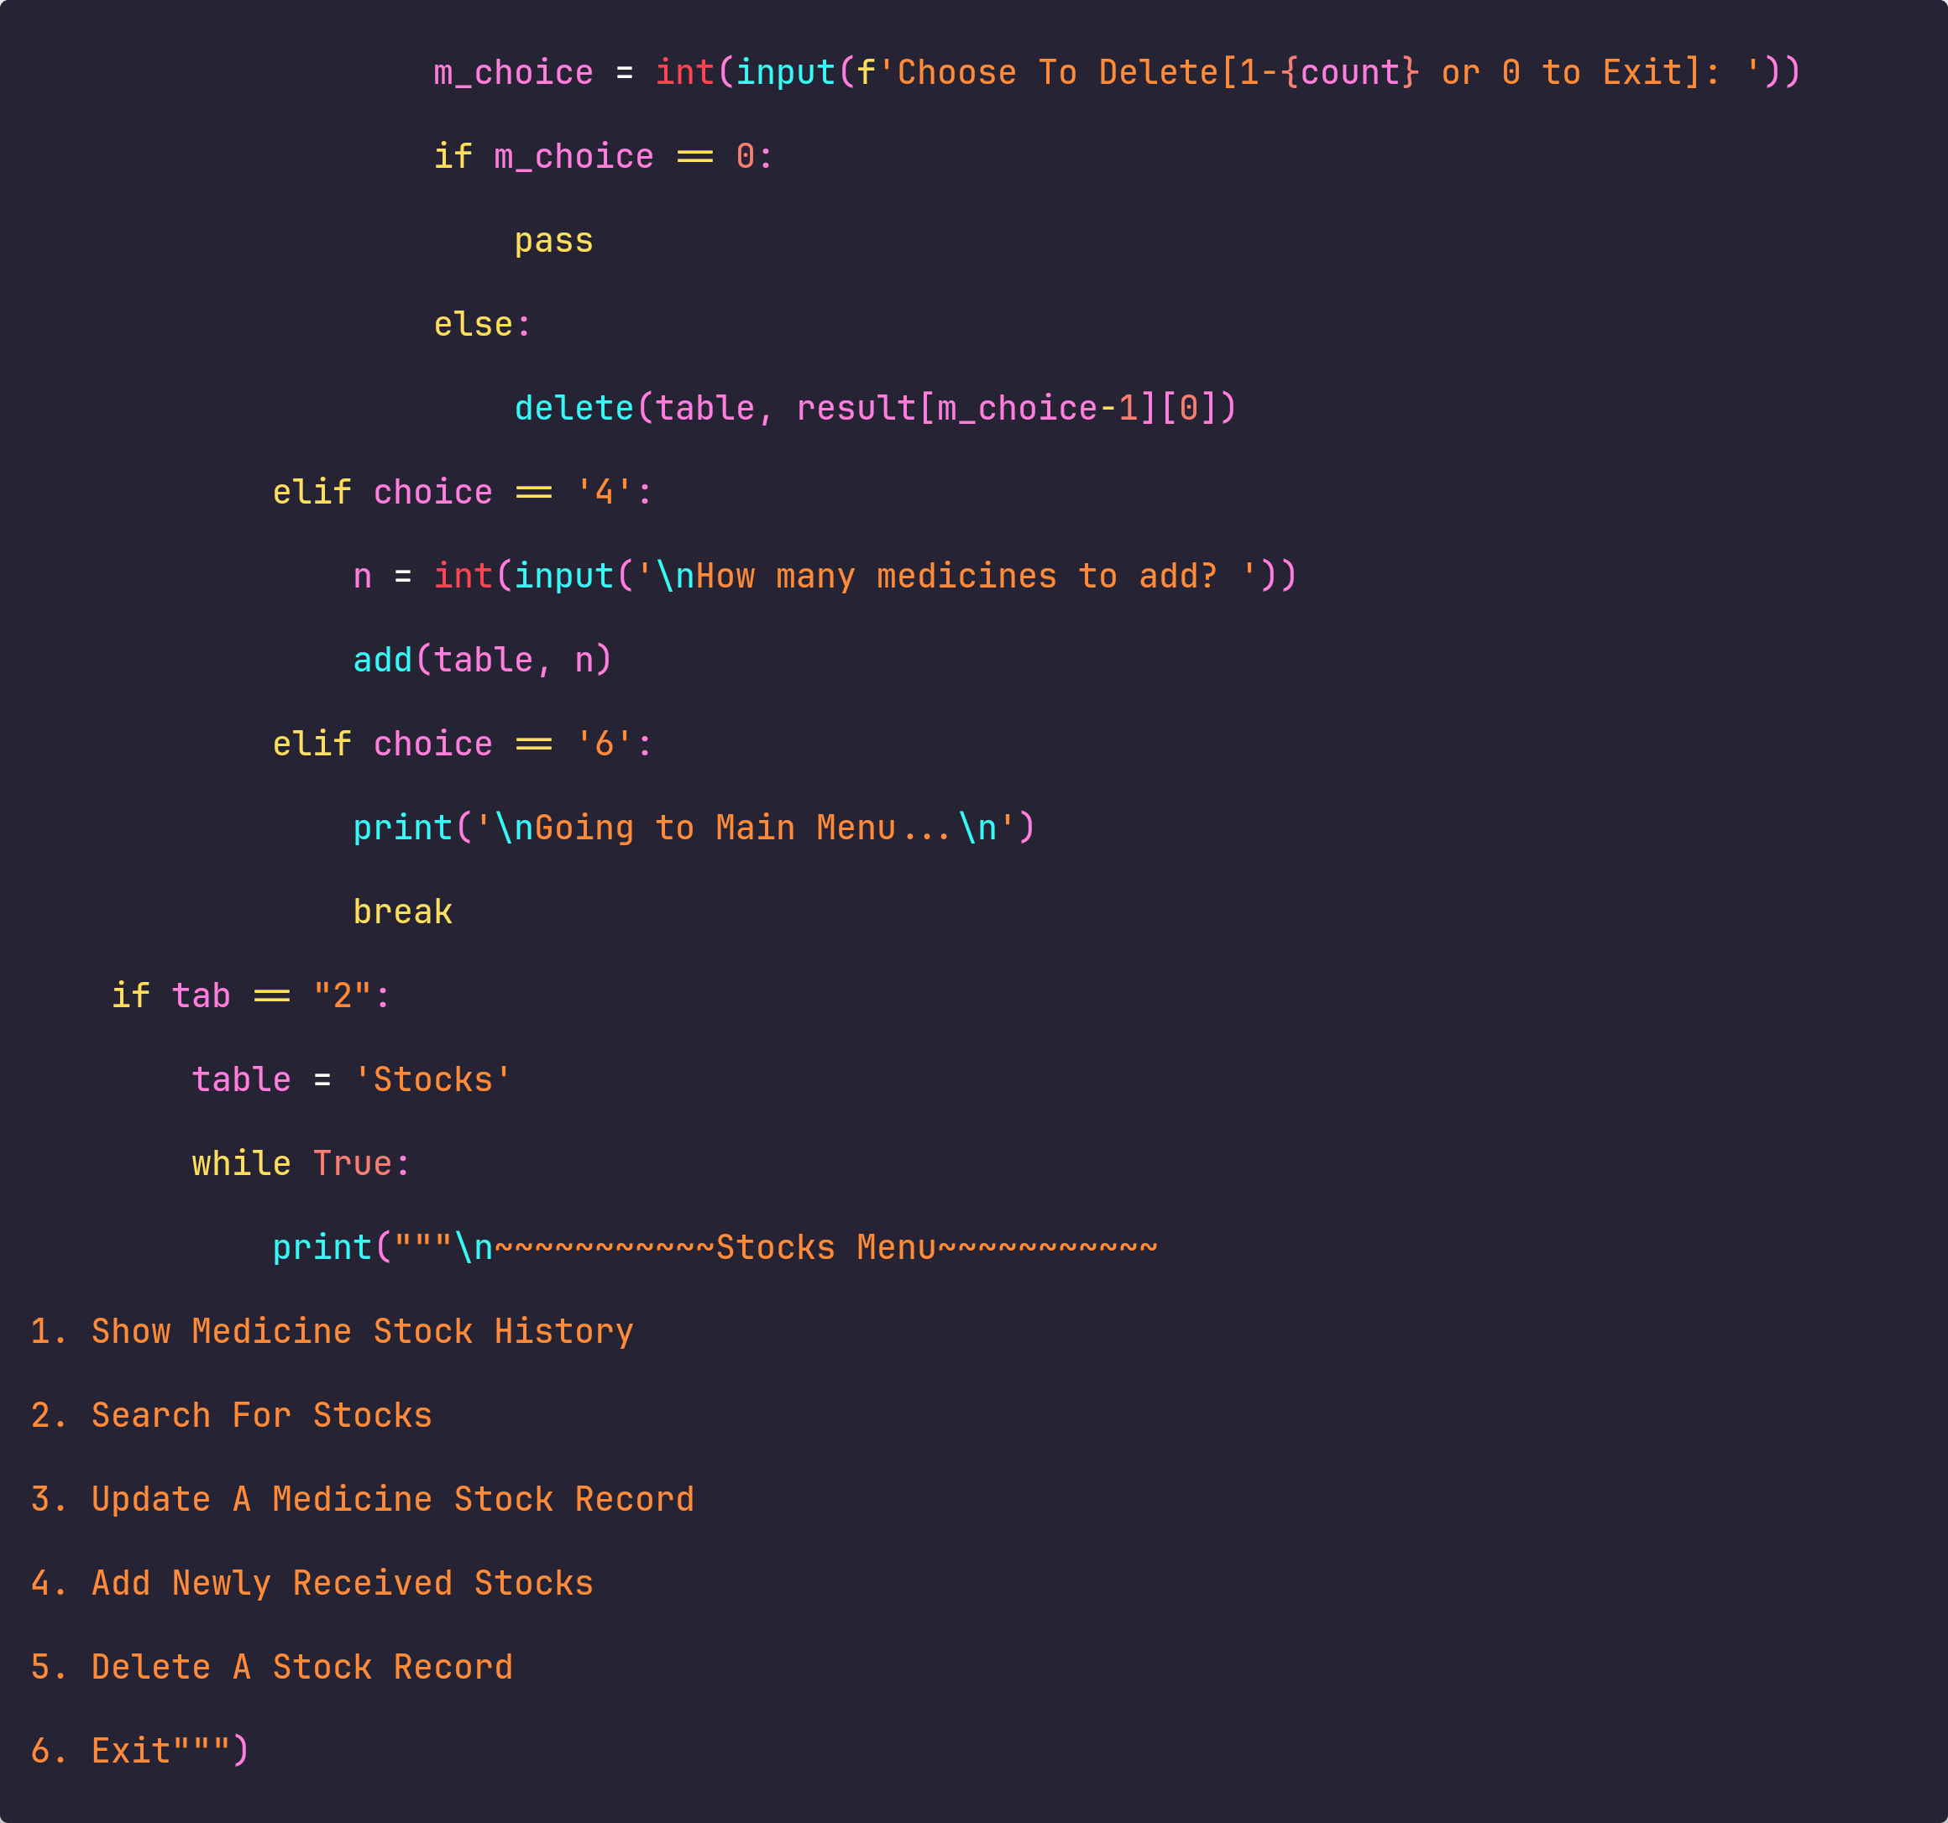

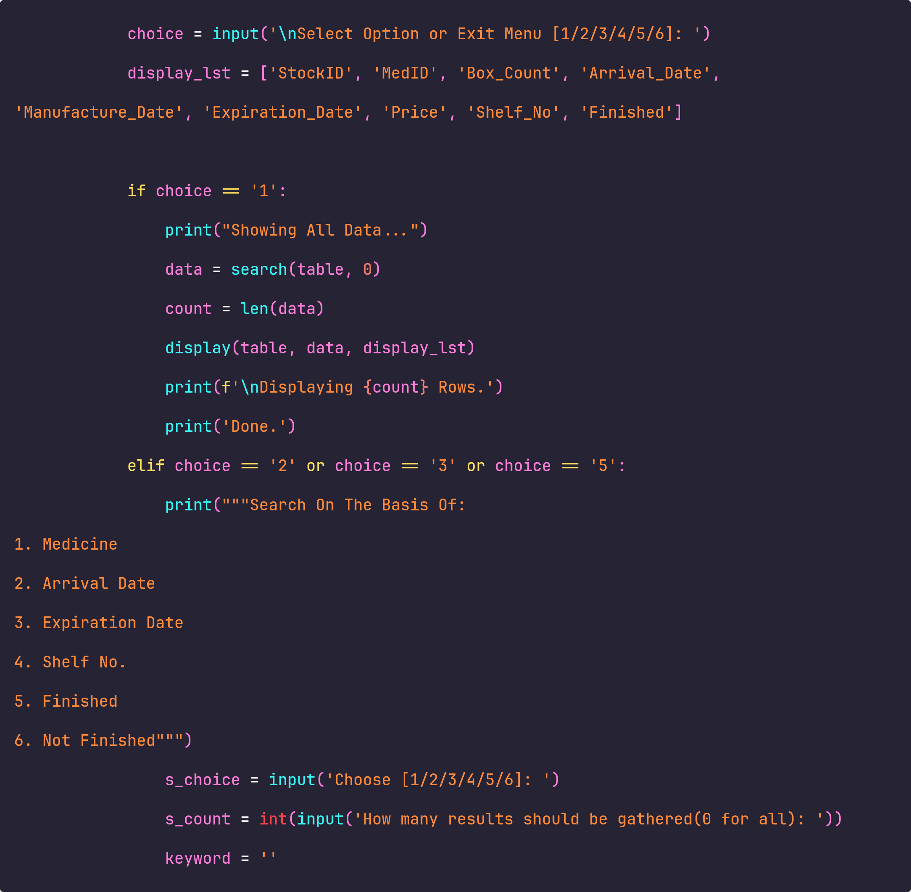

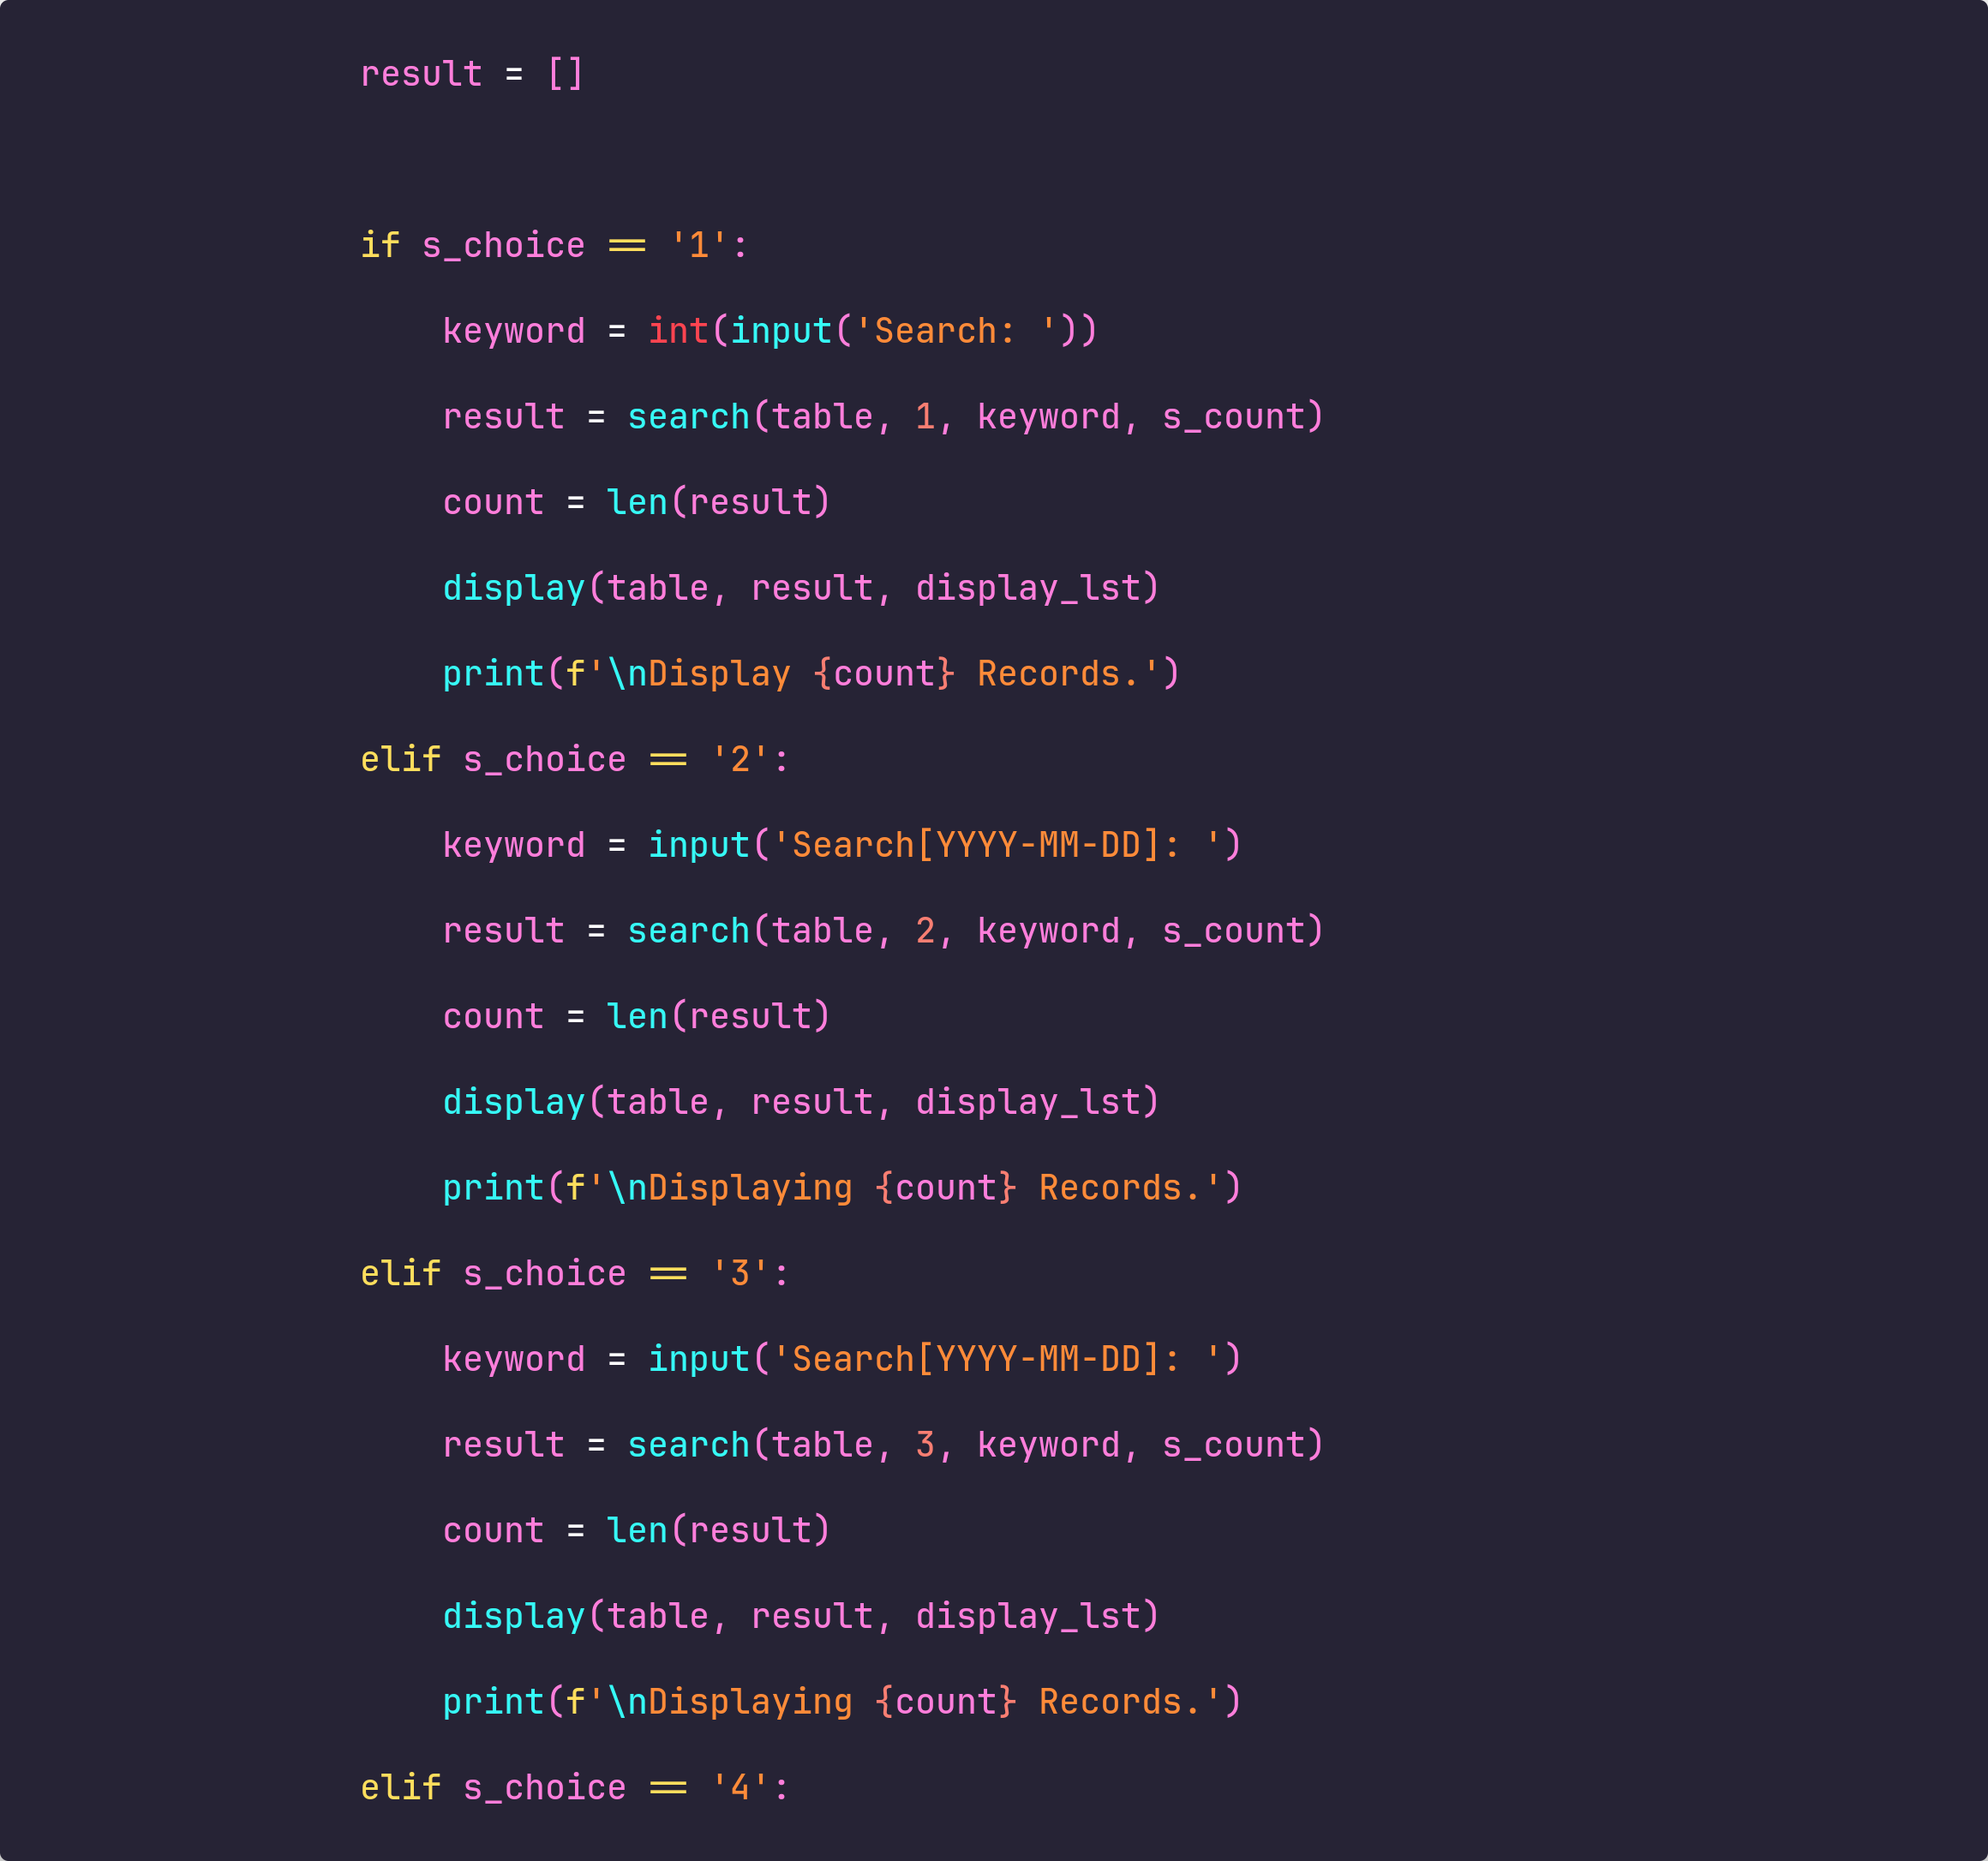

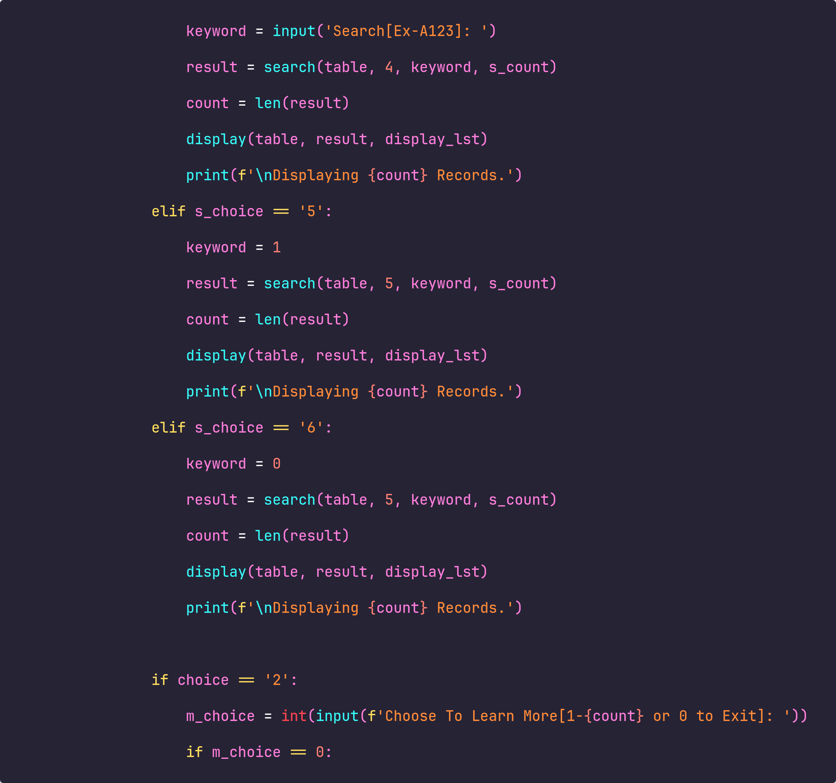

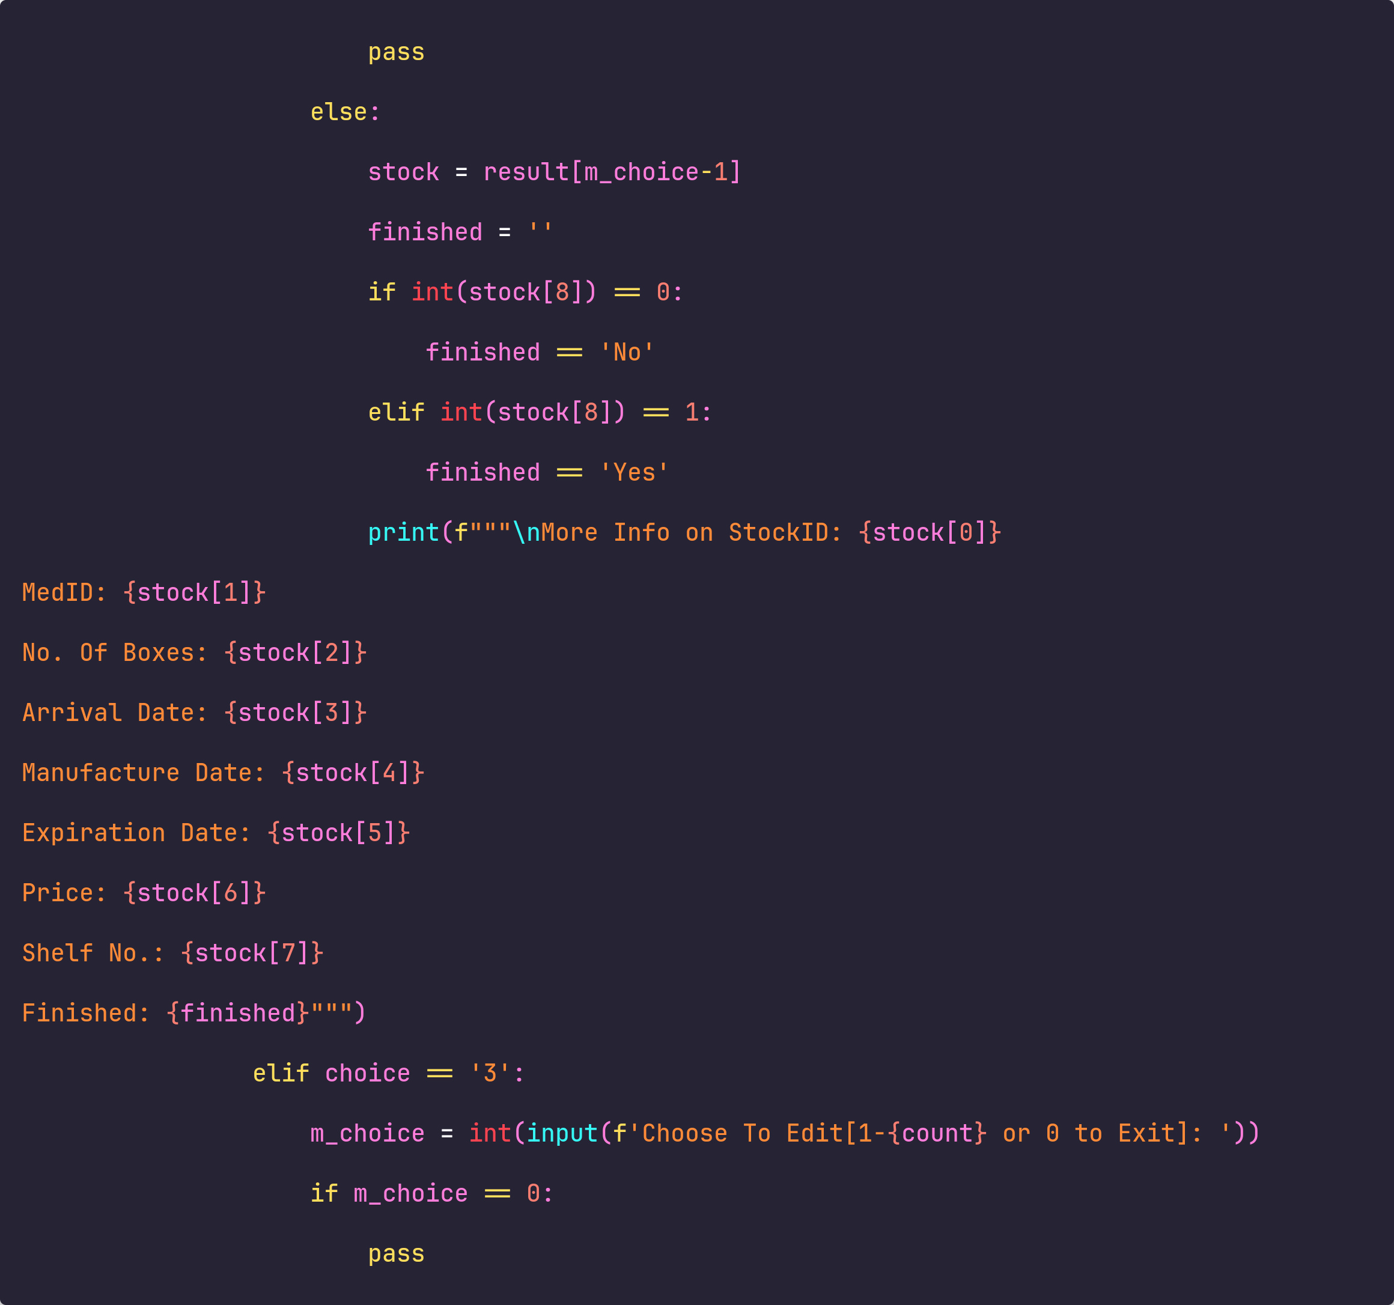

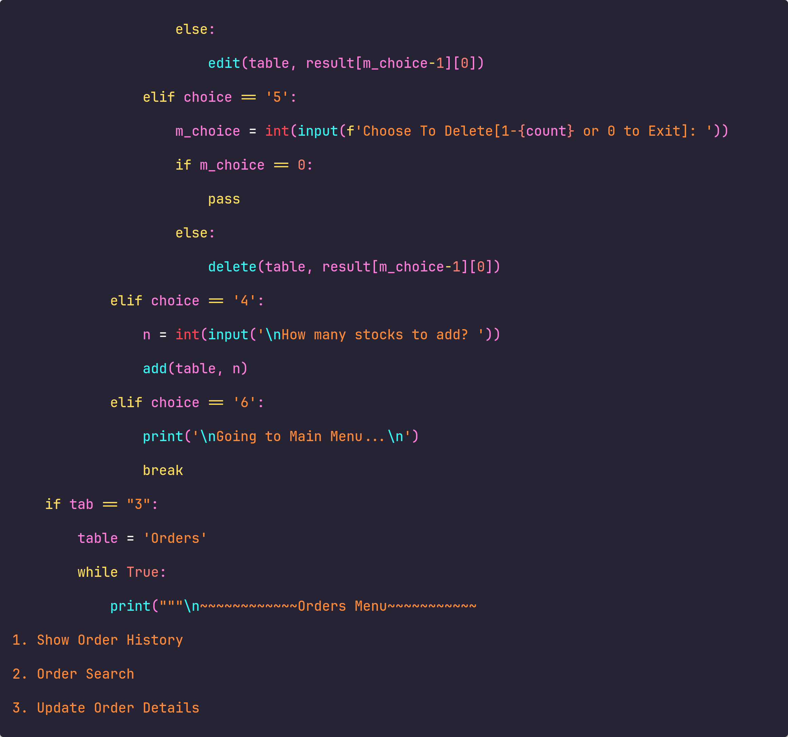

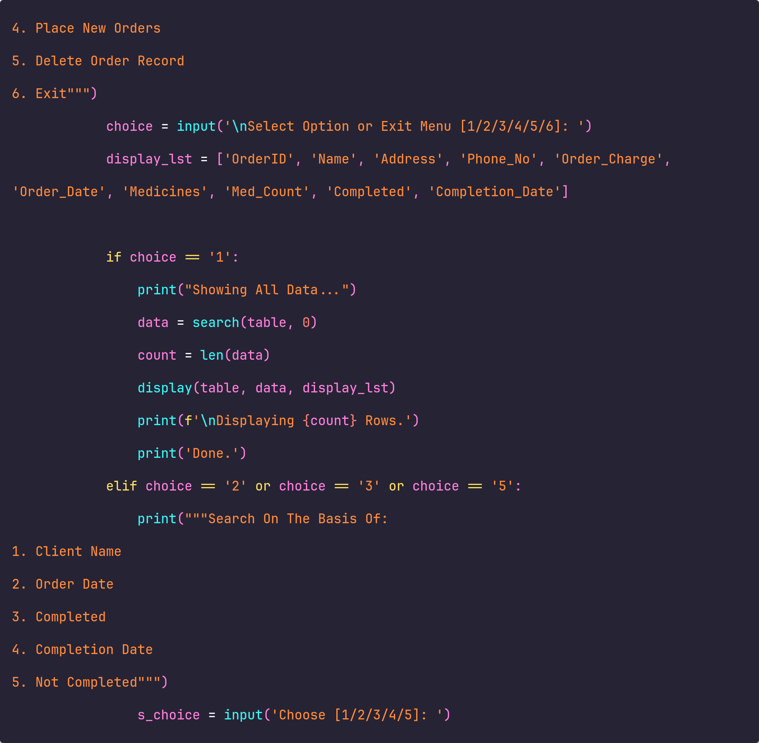

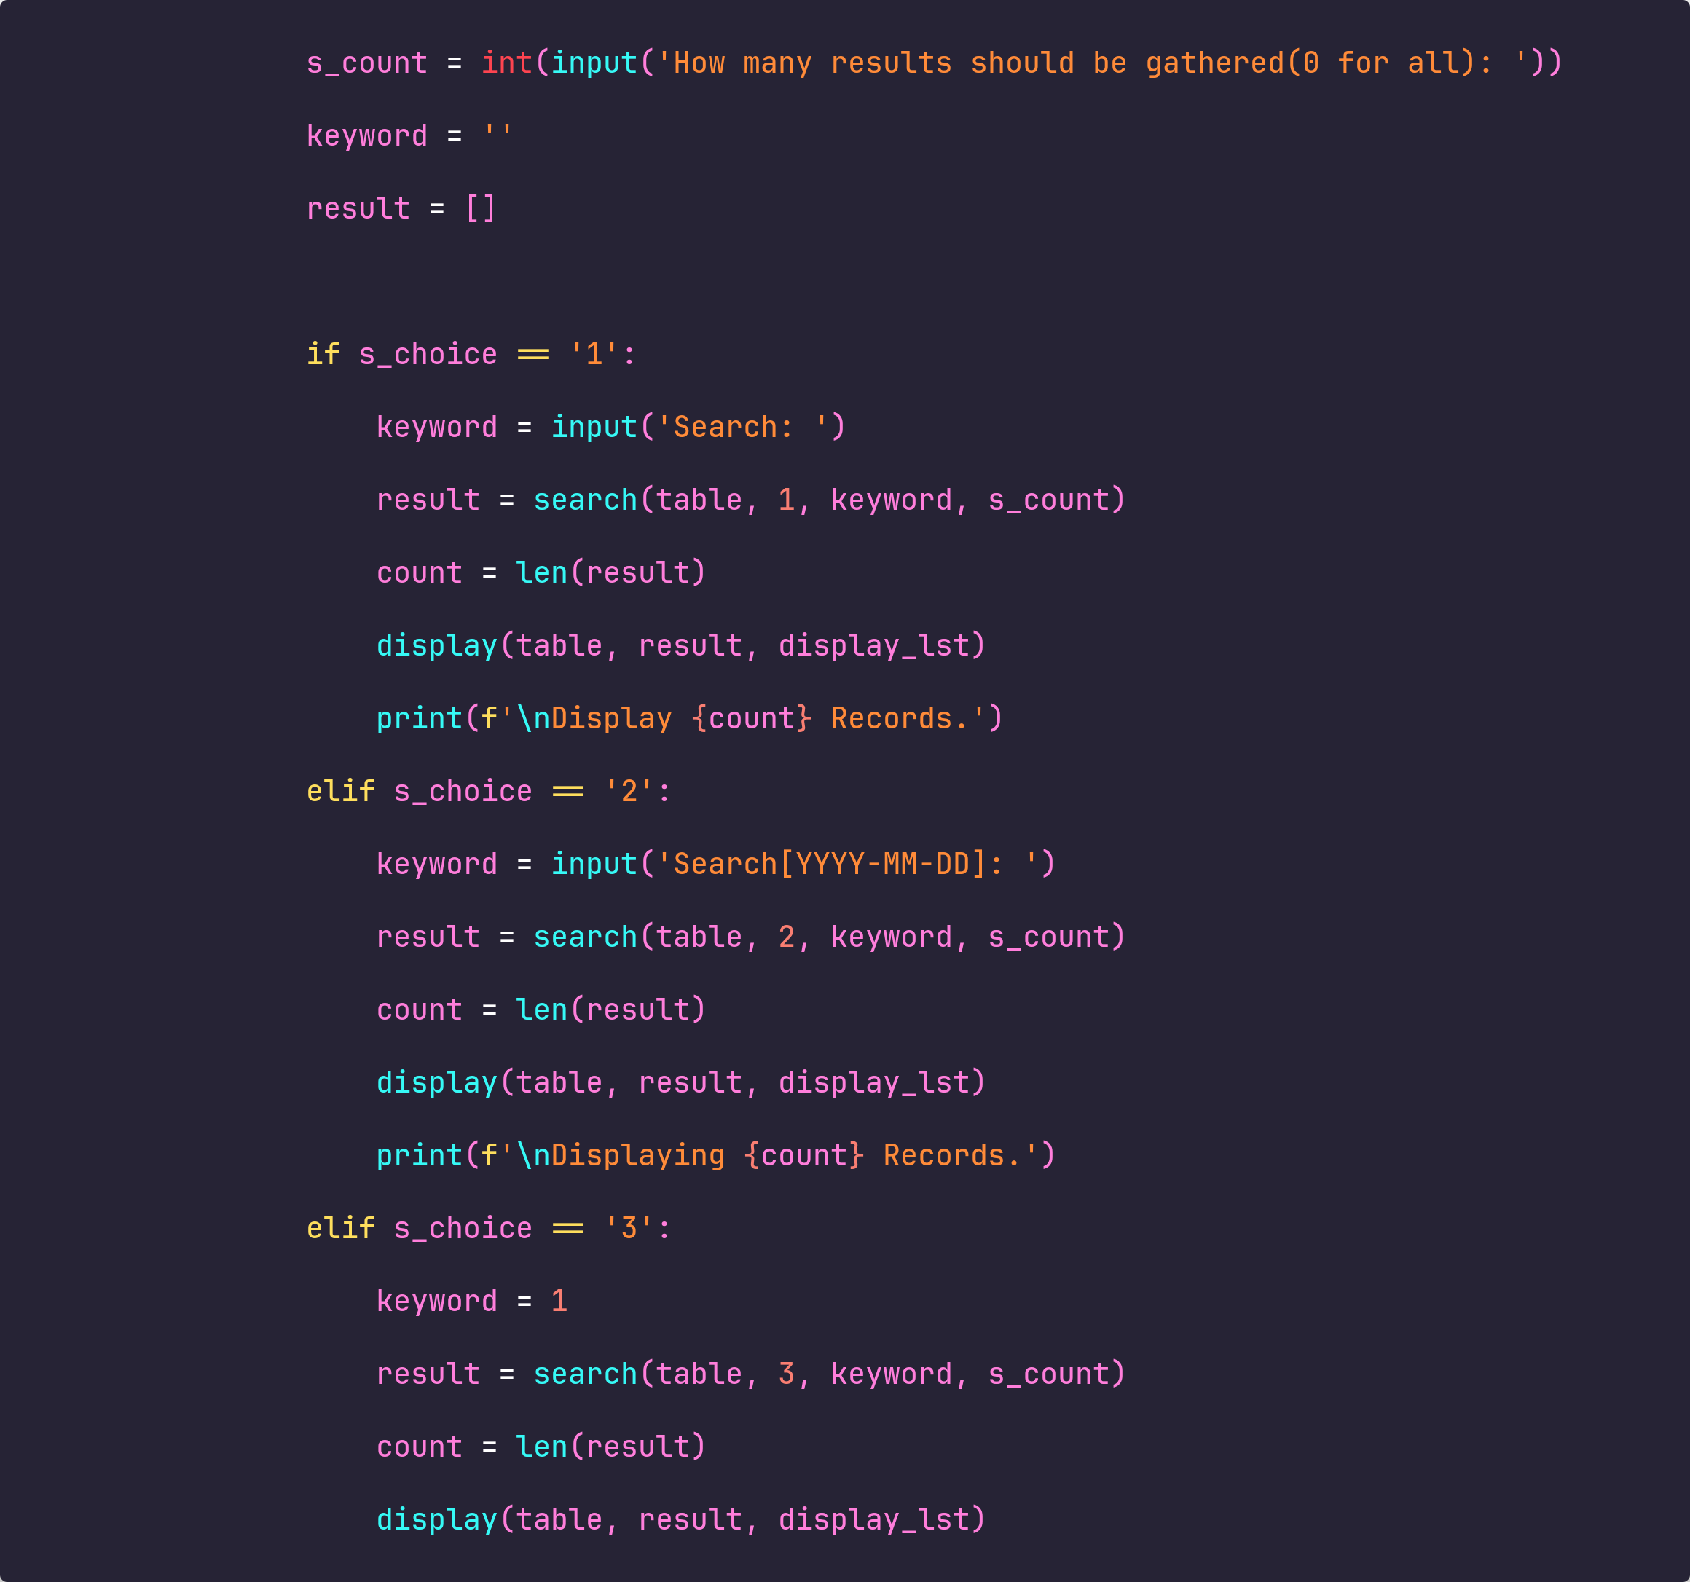

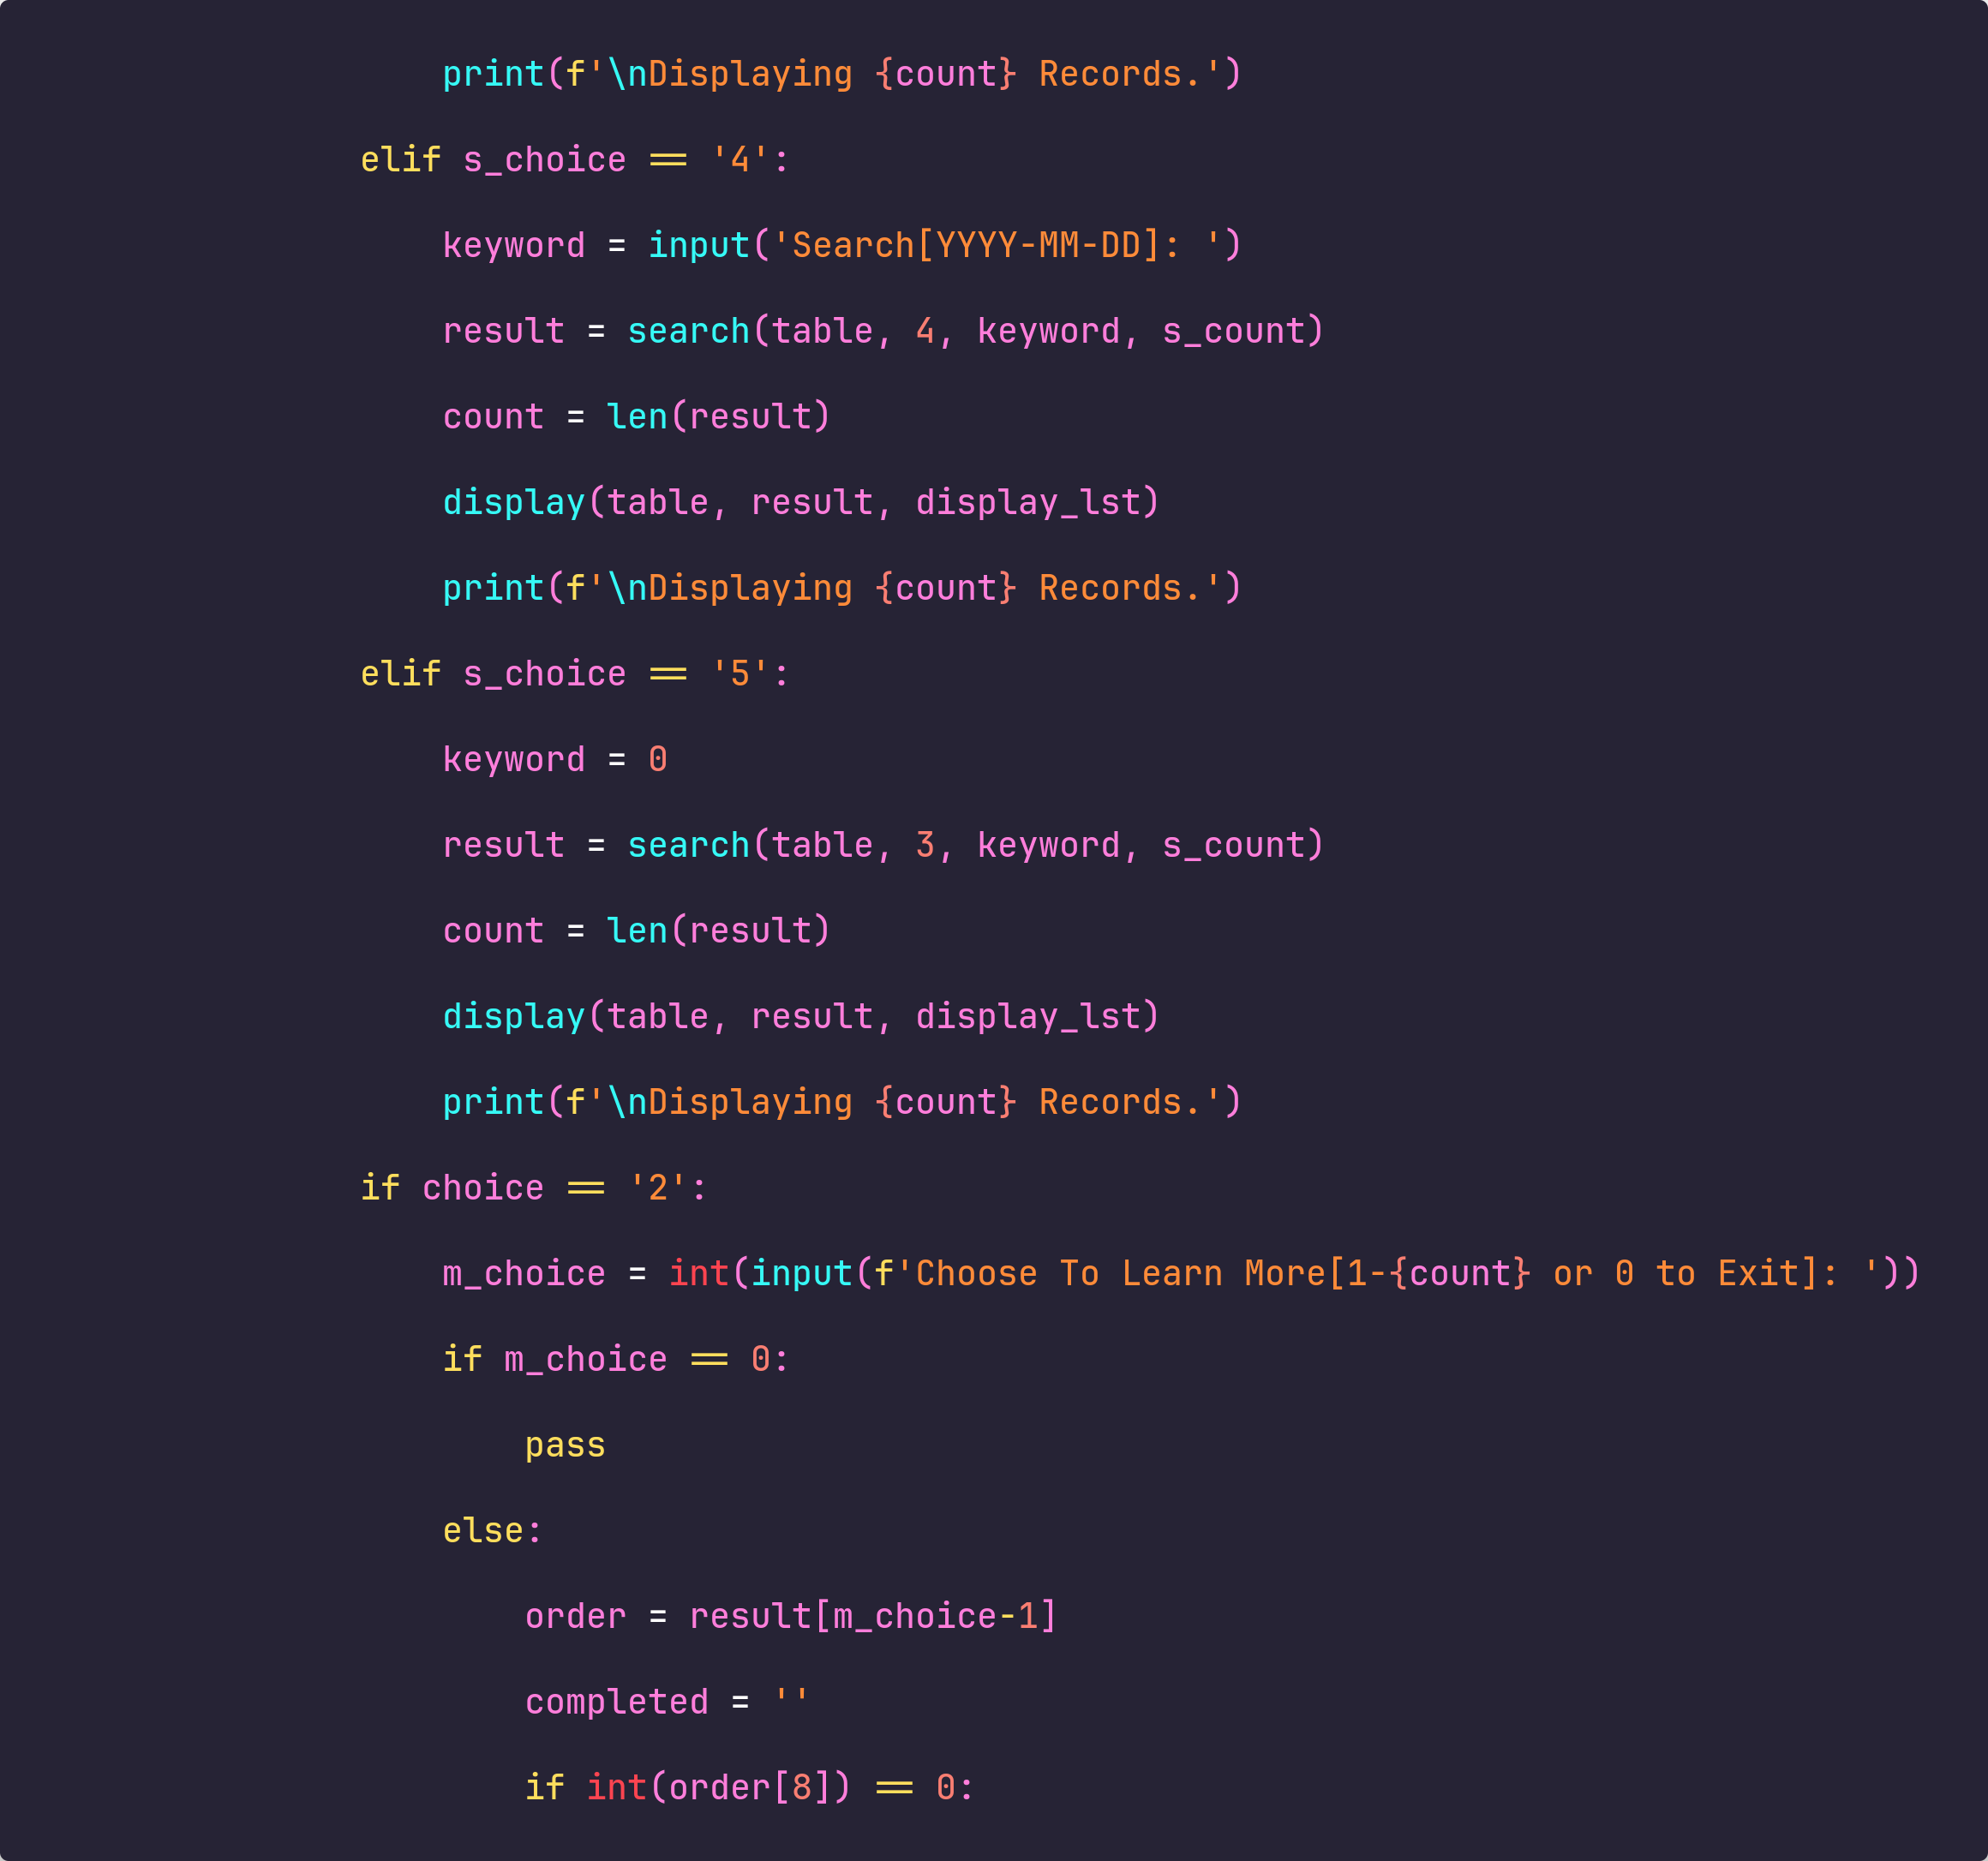

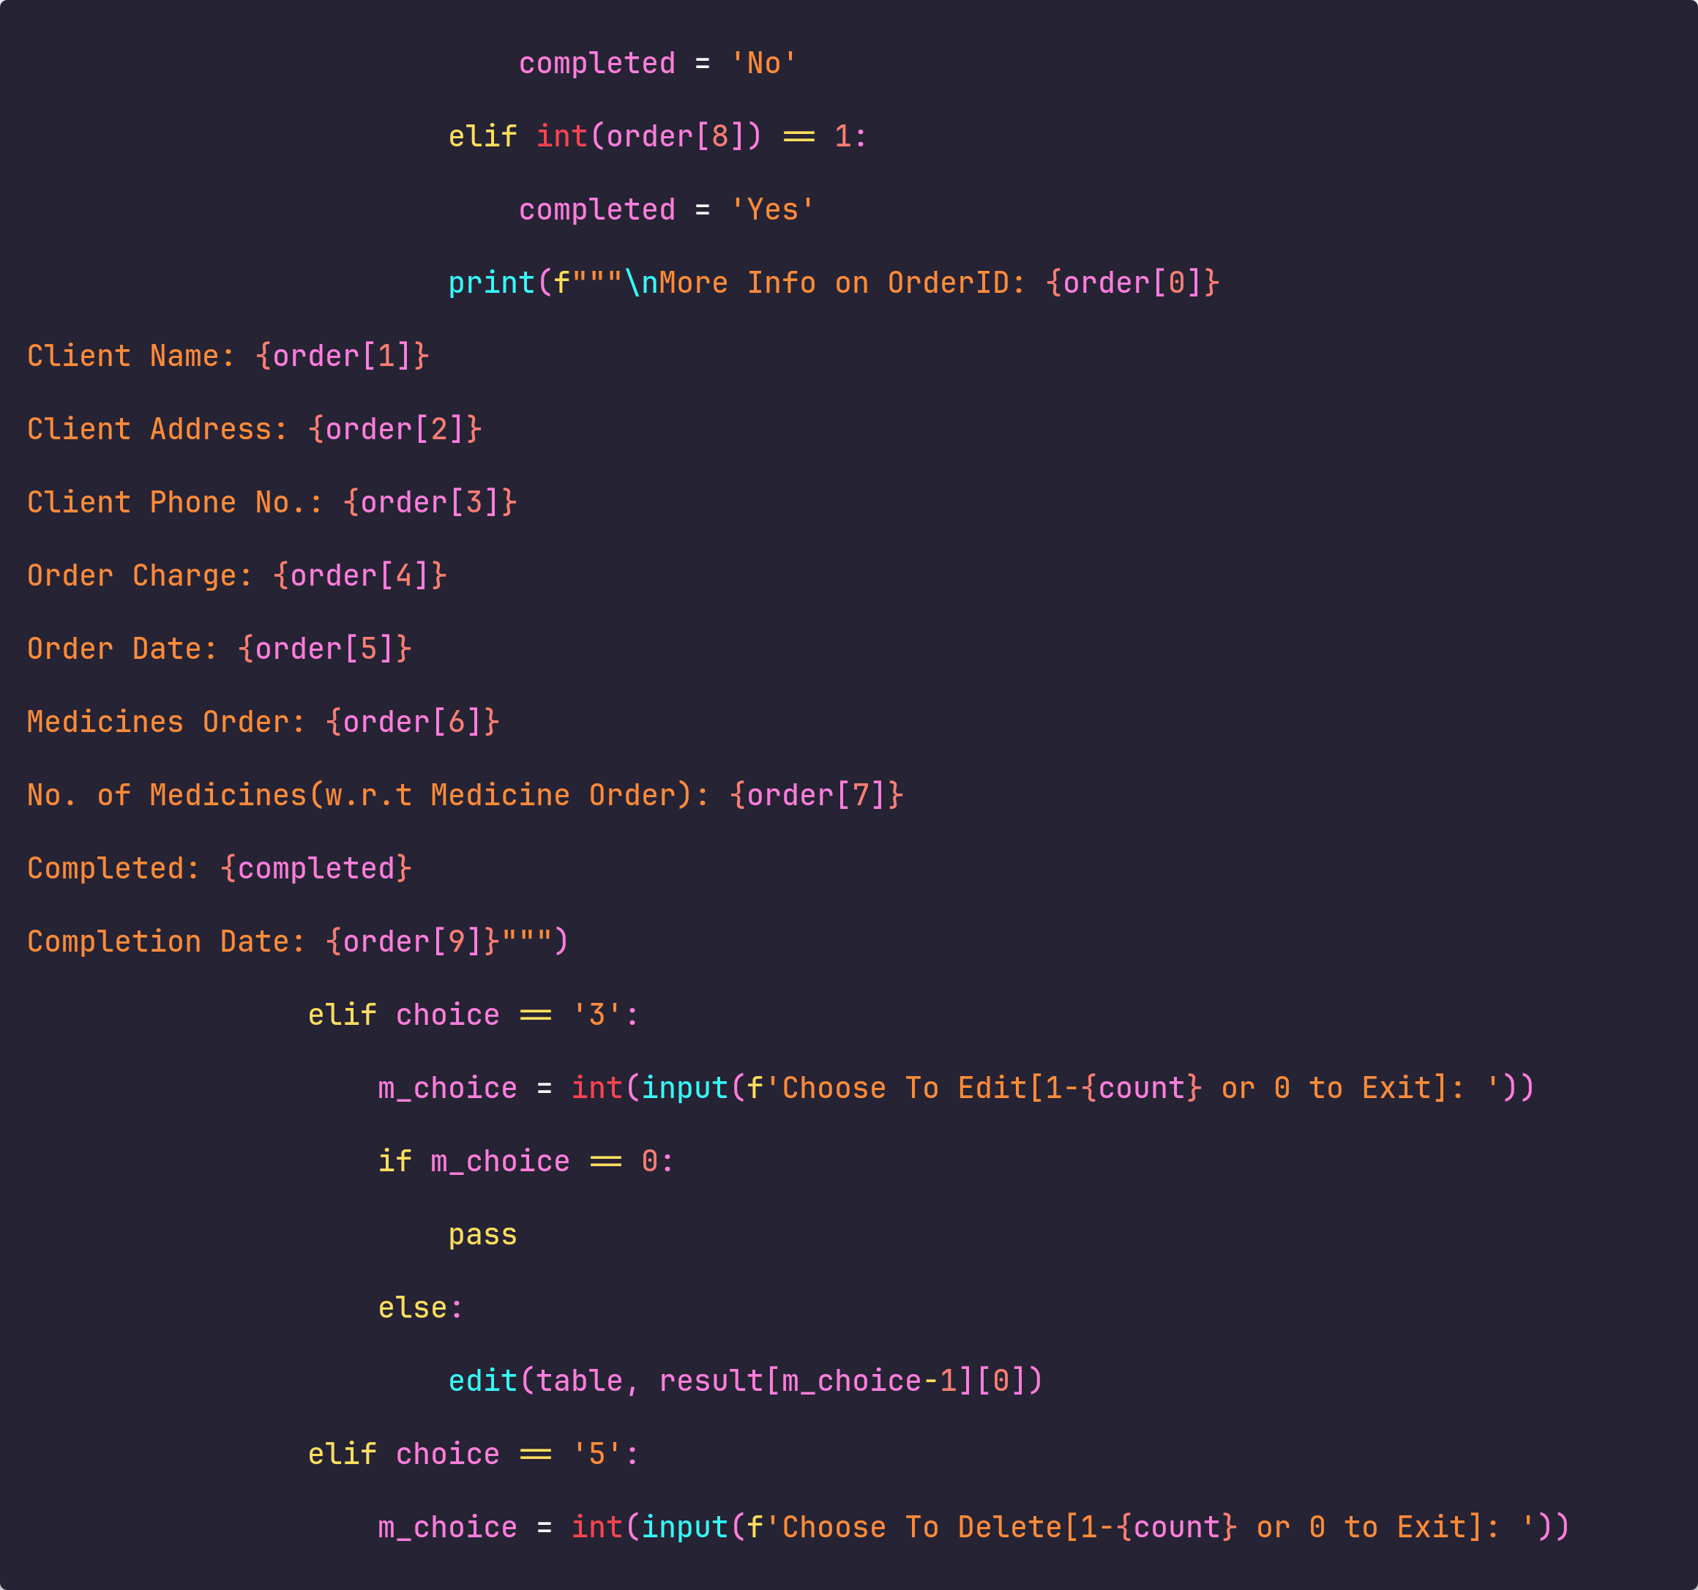

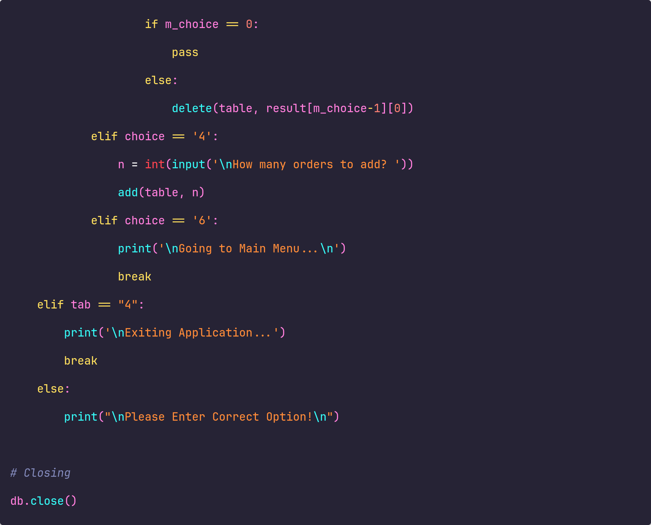

## Output

